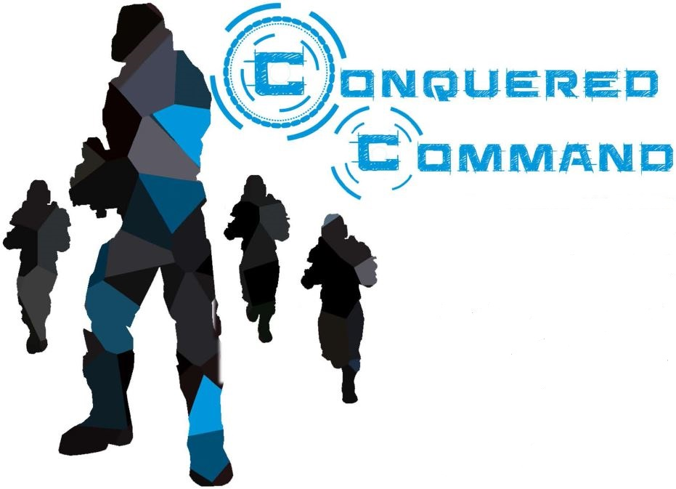

Game Design Document

Hatrock Studios

Bryan Arnold
Brett Arthur
Josh Clark
Nick Curto
Claudia Moeller
Andrew Petrilla

Contents
- Introduction…….………………………………………………………………………………..2
  - Game Story……………………………………………………………………………..2
  - Game Play……………………………………………………………………………...2
  - Game Look……………………………………………………………………………..2
  - Development Specification…………………………………………………………….2
- Game Mechanisms………………………………………………………………………..........3
  - Tactical Pause………………………………………………………………………….5
  - Click to Move…………………………………………………………………………...5
  - Switching Players………………………………………………………………………5
  - Checkpoints…………………………………………………………………………….5
  - Interface………………………………………………………………………………...6
- Artificial Intelligence…………………………………………………………………………….8
  - Teammate State Machine……………………………………………………………..8
  - Enemy State Machine………………………………………………………………….8
  - Enemy AI……………………………………………………………………………….9
  - Enemy Mob Groups……………………………………………………………………9
  - Final Boss AI……………………………………………………………………………9
- Game Elements……………………………………………………………………………….10
- Story Overview………………………………………………………………………………...13
  - Game Overview……………………………………………………………………….13
  - Player Characters…………………………………………………………………….13
  - Enemies……………………………………………………………………………….13
  - Final Boss……………………………………………………………………………..13
- Game Progression…………………………………………………………………………….14
- Credits………………………………………………………………………………………….15

Introduction

Game Story (abstract)
Trapped on a space station conquered by murderous aliens, four astronauts form a team to liberate sections and eventually the entire station from the aliens’ control.

Game Play
Conquered Command is an action role-playing game (ARPG). The player characters increase their experience level through gaining experience points by defeating enemies. At each experience level, the player characters are awarded “stat” bonus points to increase player statistics (or attributes). As player attributes increase, the effectiveness of their special combat abilities improves and more powerful abilities become available. The player characters solve puzzle components to power on sections of the space station to advance to other areas in a level and to other levels in the game. The alien enemies attack in groups. The player must plan combat strategy for the player characters to overcome the alien’s number advantage. The player can succeed in combat by utilizing three tools: real-time combat, tactical pause, and teammate preferences.

Game Look
Conquered Command exists in a Sci-fi environment. The game levels exist as maze-like wings of a space station. The “technology” of the space station and of the player characters’ weapons and special combat abilities are evocative of a futuristic world. The aliens have classic yet monstrous appearances.

Development Specification
Conquered Command is made with the Unity (version 5) game engine. The game’s scripts in written in C#. Model, UI, and particle system assets are from the Unity store. The game is being developed for PC, Mac, and Linux. Development time for this game is 4 months.

Game Mechanisms

Abilities
Abilities are actions the player can take to harm enemies or aid themself or their team. When the game starts the player only has one basic ability, shooting an assault rifle. The player can unlock the abilities listed below by acquiring stat points. Stat points are rewarded for defeating enemies. Players can allocate these points into one of the following categories: Intelligence, Stamina, and Strength. The following tables include information about each ability.

Strength
Name | Icon | Requirement | Description
Grenade Throw | 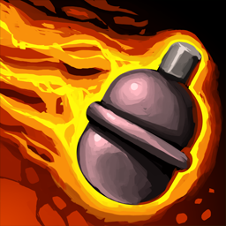 | 5 STR | Throw a grenade to damage enemies within the area of effect.
Flamethrower |  | 10 STR | Equip a Flamethrower for 8 seconds. Use with left mouse button.
SMG | 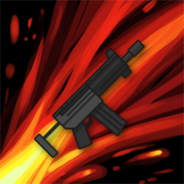 | 15 STR | Replace basic attack with a faster firing SMG.
R.I.P. Rounds | 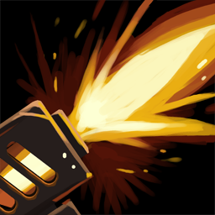 | 20 STR | Equip higher impact rounds to your gun to double your strength. (Passive ability)

Intelligence
Name | Icon | Requirement | Description
Medkit |  | 5 INT | Heals the user for a small amount of HP.
Revive | 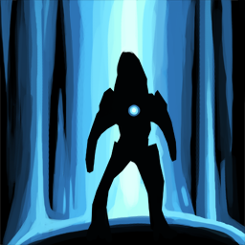 | 10 INT | Revive a downed teammate or heal an alive teammate.
Sniper Rifle | 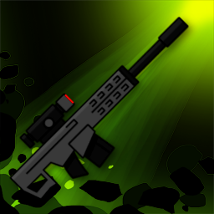 | 15 INT | Replace basic attack with a long-range, high damage sniper rifle.
BioGrenade |  | 20 INT | Deploy a healing shield to regenerate health to all teammates within the circle.
Stamina
Name | Icon | Requirement | Description
Zap |  | 5 STM | Attack a single enemy target with a powerful lightning strike. Stuns the enemy.
Shield Booster |  | 10 STM | Increase the defense stat of teammates for a short time.
Shotgun | 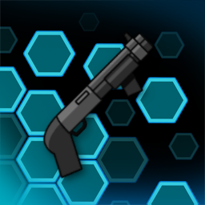 | 15 STM | Replace basic attack with a short-range shotgun blast that affects multiple targets.
Chain-Lightning | 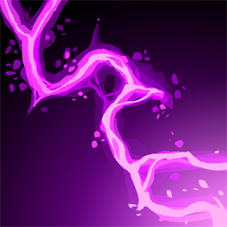 | 20 STM | Attack with a lightning strike that chains between several enemy targets.

Strength/Intelligence
Name | Icon | Requirement | Description
Leech Dart | 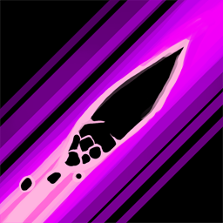 | 5 STR / 5 INT | Attack a single enemy target and the user heals for half the damage inflicted.
Invigorate |  | 10 STR / 10 INT | All other special abilities will be instantly ready to use.

Strength/Stamina
Name | Icon | Requirement | Description
Flame Wall | 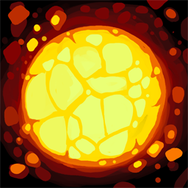 | 5 STR / 5 STM | Shoot a wall of fire towards a target. Deals burn damage.
Shockwave |  | 10 STR / 10 STM | Knock back all enemies within the effect radius. Deals minor damage and stuns enemies.

Intelligence/Stamina
Name | Icon | Requirement | Description
Stimpak | 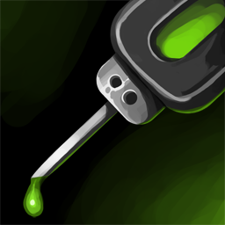 | 5 INT / 5 STM | Instantly regain depleted energy and deal extra damage over a short time.
Sentry Turret | 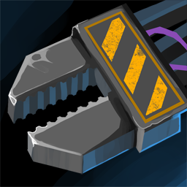 | 10 INT / 10 STM | Deploy a sentry turret that targets nearby enemies. Self-destructs after 10 sec.
Basic Abilities are used by right-clicking on an enemy. Special Abilities are used by pressing the corresponding key on the ability bar, then doing further action with left-click. As the player acquires more points in all of the listed categories they will have the option to upgrade their basic weapon to deal more damage to enemies.

Tactical Pause
The player may enter tactical pause (spacebar) at any time. If the team is not in combat, the player can enter the ability selection screen (c) to allocate stat points. Once the allocations are confirmed (pressing the confirm button) they cannot be removed. The players list of available abilities will update immediately. The player can drag four special abilities and one basic ability to their selected ability bar. Each slot in the special ability bar corresponds with a key on the keyboard. The player can decide which keys correspond with the slots in the setting menu. After exiting out of tactical pause, the player can use their selected abilities by pressing the key of the ability desired then clicking on the target.

Click to Move
The user can click anywhere in the game to move there. If the location clicked is not walkable, the player will move to the closest walkable area. The inactive players will follow if they are not engaged in another activity.

Switching Players
The user can press tab to switch the active player. The game will move through the players in the following order- Player1, Player2, Player3, Player4, provided the next player is not dead.

Checkpoints
Checkpoints located at computer terminal objects that allow the user to save the game if desired. The player can save the game under a new name or overwrite a previously saved game.

Interface
Conquered Command is designed to be played with a keyboard and mouse. The following tables show the default control settings.

Player Controls
Key | Action
Right Click | Move/Shoot
Left Click | Use Ability / Shoot
Alpha1 | Switch to Player 1
Alpha2 | Switch to Player 2
Alpha3 | Switch to Player 3
Alpha4 | Switch to Player 4
Tab | Cycle to next available Player
Q | Use Ability 1/Cancel Ability
W | Use Ability 2/Cancel Ability
E | Use Ability 3/Cancel Ability
R | Use Ability 4/Cancel Ability
Space | Enter Tactical Pause

Tactical Pause Controls
Key | Action
C | Open Character Ability Screen
Tab | Switch Player View
Alpha 1-4 | Switch Player View

Debug Keys (removed from final build)

Key | Action
P | Add Stat Points
H | Hurt Team by 10 HP
M | die

Camera Control Keys
Key | Action
Mouse Scroll Wheel | “Zoom” in/out
- | “Zoom” out
+ | “Zoom” in
A | Revolve camera clockwise
S | Revolve camera counter-clockwise
Z | Behind active player perspective toggle

Checkpoint Keys
Key | Action
F | save
N | next level

Puzzle Keys
Key | Action
F | Interact

Artificial Intelligence

Teammate State Machine
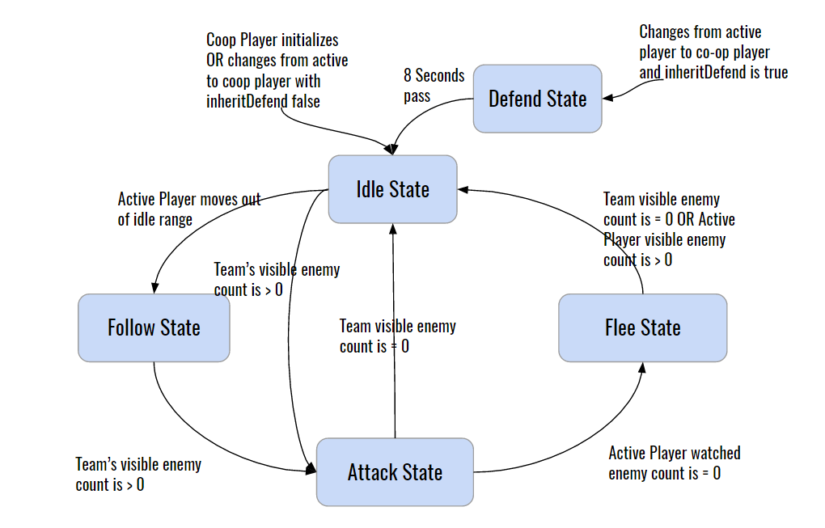

Enemy State Machine
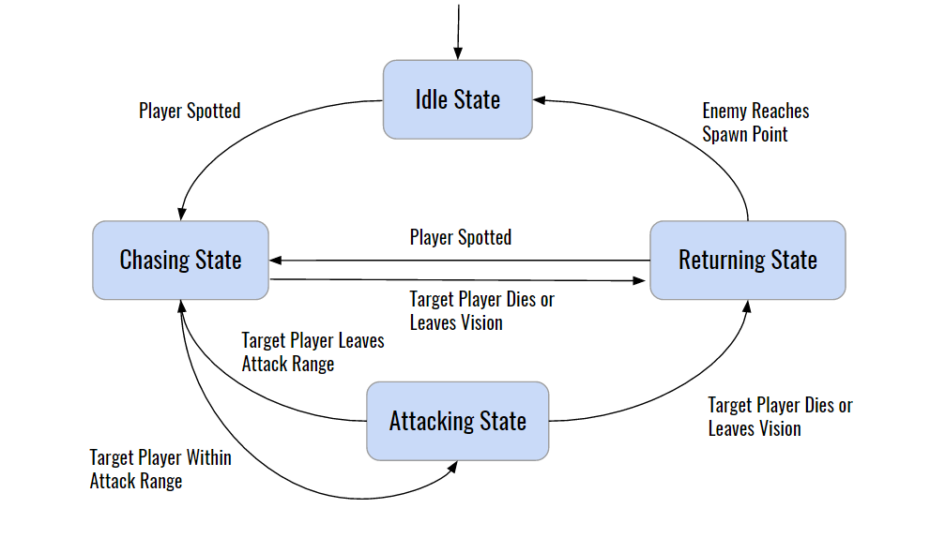

Enemy AI
Each enemy has individual vision sphere that triggers whenever a player enters them. They perform raycasts to players in their vision sphere to detect if vision is occluded by scenery. Upon successful raycast, enemies will enter an aggroed state, where they will chase players until either the enemy dies, all players in vision die, or no more players can be seen. When enemies enter a certain range of the player, they will enter an attacking state. Attacking animations contain animation events that deal damage to the players.

Enemy Mob Groups
In addition, enemies can share their knowledge of visible players within their enemy mob group, which is a pooled knowledge resource for nearby enemies. Enemy mobs can use two different strategies to determine targets for the enemies within the mob:
- Even - Enemies will distribute evenly amongst all players in the mob’s vision
- Random - Enemies will randomly choose their targets from those within the mob’s vision

Final Boss AI
The boss character uses a vision sphere trigger that, once a player character enters it, will give the boss AI an omniscient view of the player characters’ locations indefinitely. The final boss will remain stationary, and does not perform any raycasts to detect for vision occlusion. However, after each attack the boss performs, it will randomly choose another player character to target and another attack to execute. There is additional logic implemented so that the boss will favor not performing the same attack twice in a row, or targeting the same player two attacks in a row.

The five attacks the boss can choose from are:

- Sweep Attack - The boss character will shoot four small projectiles in an arc towards the current target. These projectiles will disappear if they collide with a player.
- Plasma Beam Attack - The boss character will shoot a laser in a line forward towards the current target and will follow that target by turning. The laser deals damage over time.
- Explosion Attack - An explosion erupts from around the boss character, dealing damage in a circle around them. This attack is favored if a player character is too close to the boss.
- Blast Attack - A large sphere projectile is shot towards the current target character, dealing large amounts of damage and persisting even after colliding with a player.
- Spawn Attack - The boss spawn a small damaging field under the targetted player that deals damage over time for any player standing in the field. This attack is always performed if the current target is far away from the player, in order to deter players from running away and healing for extended periods of time.

Game Elements

- Game Goal
In order to take back the Space Station, the team must make their way through three wings of the space station, to take back control of the command center.

- Level Terms

Wing - this is equivalent to a game level. The players must progress through a wing to get to the next wing (level).

Objective - This is a generalized “mission” that must be completed in order to progress further throughout the wing. This provides structure and direction in gameplay.

Goal - Within an objective, there are more specific goals to complete to ultimately complete an objective. They do not have to be completed in order.

Generator - A generator is a game object that the user can interact with to turn on different parts of the level or turn on different game objects. This could involve doors, other generators, or consoles that the user needs to interact with. Generators may be “broken” and need fixed through solving a puzzle.

Console - A device on the space station that displays a user interface for the player to interact with.

Types:

- PUZZLE CONSOLE - these consoles display a puzzle that must be solved in order to accomplish a goal.
- CHECKPOINT CONSOLE - these consoles display a UI that the user can interact with to save their progress in the game.

Puzzle - a problem that the player must solve to power on a generator, open a door, or turn on a console.

Types:

- UI Puzzle (or Console Puzzle) - this is the puzzle that is displayed on the console. The puzzle starts out in an Error state, indicating to the user something must be done in order to fix the problem. This puzzle is a pipe connector game where the goal is to make sure there are no openings on the pipe connectors. The user must click the individual connectors in order to rotate them toward one another, so certain end connect to one another.
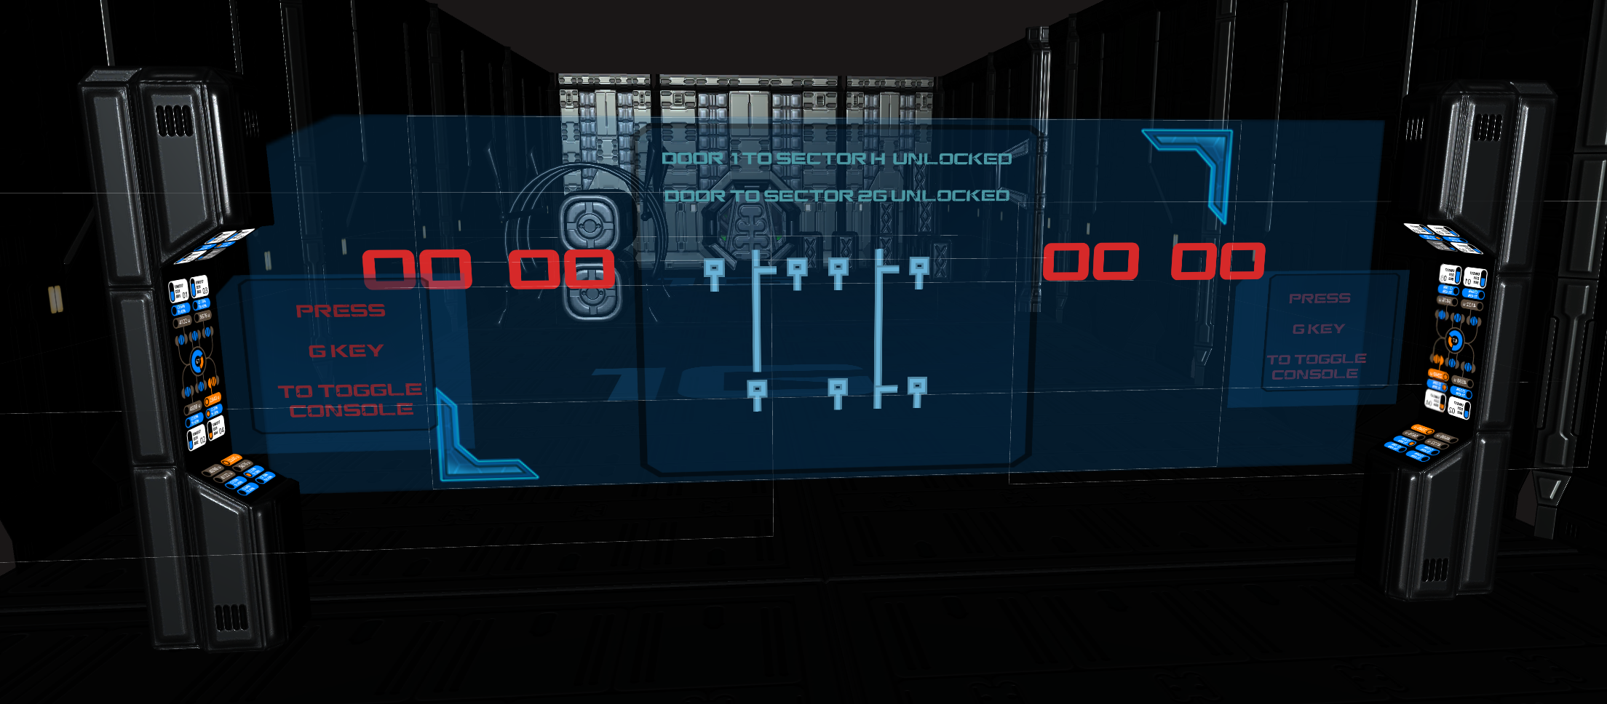

- Circuit Puzzle - The puzzle is a labyrinth of logic gates and connectors that must be activated in the correct way to solve the puzzle. Each gate has two inputs and one output. Button terminals are simple on/off switches that send true/false values to their connecting hub. A hub will hint at its gate association through color.

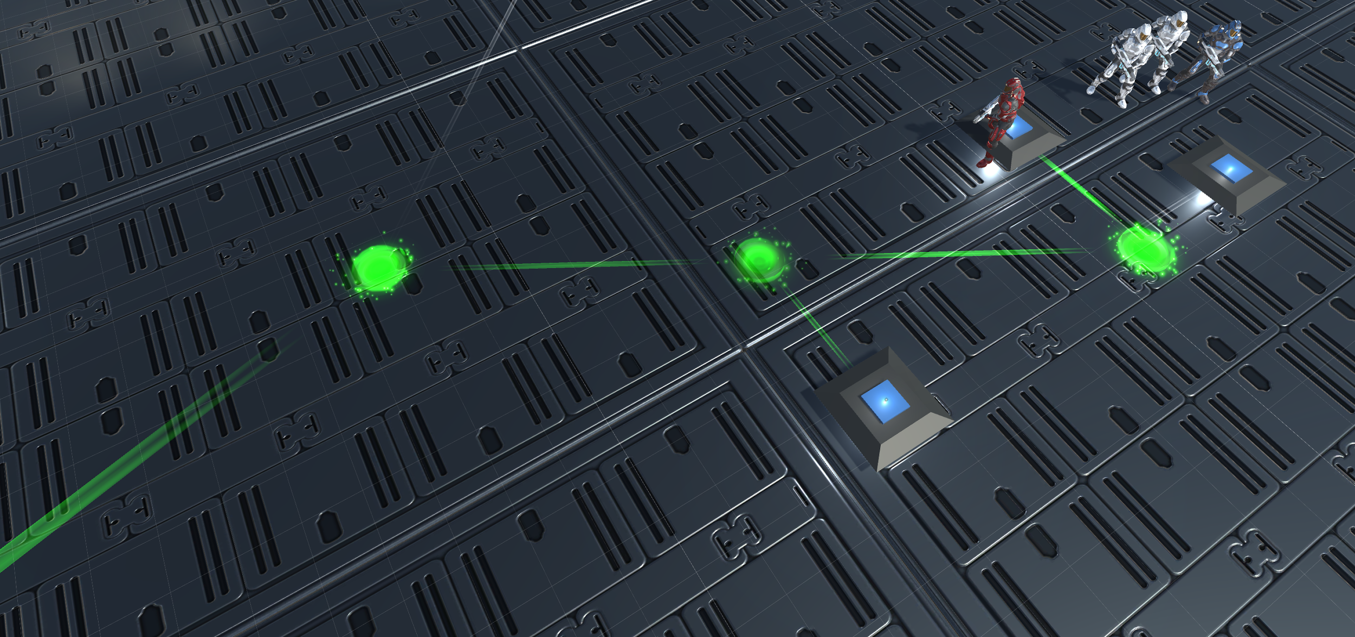

- Clock Puzzle - A special puzzle that must be solved by setting the correct time by pressed the correct “hour” and “minute” buttons.

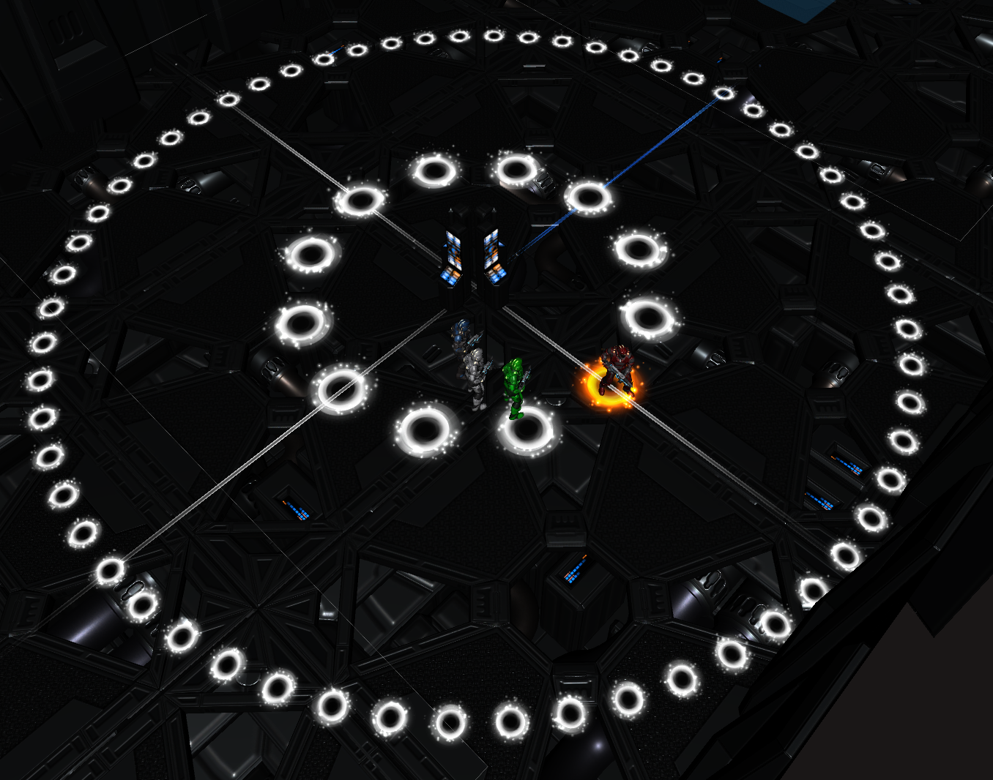

Story Overview

Game Overview
On an isolated space station, four astronaut marines find themselves alone in a fight to retake control of the station from an assault force of murderous aliens.

Player Characters
The four astronaut marines are identifiable by the colors of their spacesuit armor: red, white, blue, and green. The character statistics (strength, intelligence, and stamina) can be increased by allocatable bonus points which are gained by advancing through experience levels. By allocating points and setting active abilities, the player can decide what roles each character plays on the team (e.g. healing focus).

Enemies
The aliens populate various locations of the space station and attack the player characters on sight. The basic alien is small, classic-look alien. The beetle alien form has three levels of tougher and stronger than the basic alien. Their difficulty is varied by adjusting their attack damage and health amounts:

Easy
Hard

Final Boss
The final boss at the end of out game is Xan’tul, the Alien Commander. This character is designed to be a unique enemy in that she is very strong and will use high damage ranged attacks to eliminate the player’s team. Defeating this boss will be the final objective for players to complete in order to beat the game.

Game Progression
As the player characters gain experience by defeating enemies, they will advance through experience levels. When reaching a new experience level, each character is given a set number of bonus points that the player can allocate to the character’s statistics (strength, intelligence, or stamina). Special abilities are unlocked as a character’s statistics reach certain values. Higher statistic values unlock more powerful abilities than increase the character’s combat effectiveness. As the player takes the characters through each level, the player must solve puzzles, defeat enemies, and achieve listed objectives. In the final level, the player needs to defeat the final boss alien in order to win the game.

Level 1 is significantly large, but it combines elements of being a tutorial level in addition to being a regular game level. The initial puzzles are simple enough to give players a basic idea of how the puzzles work. Initial battles are simple with player characters starting with just basic attack abilities. Later battle increase in difficulty and player strategies become more complex as player characters gain more combat abilities

Level 2 is smaller, but more difficult. Overall, the level is less maze-like than Level 1; the paths to complete the level are simpler. The puzzles are designed to be more connected to each other. The number of enemies and the difficulty of defeating them is balanced against what the player character’s experience level should be.

Level 3 is a more combat-intensive level with a basic direct path that leads to a final boss fight before the player can reach the game’s win state.

Credits
The Ohio State University, CSE 5912 Capstone Design: Game Design and Development, Spring 2017, Dr. Roger Crawfis

Hatrock Studios: Bryan Arnold, Brett Arthur, Josh Clark, Nick Curto, Claudia Moeller, Andrew Petrilla

