Games Out For Harambe

Not Golf

Game Design Document

Dylan Barrow
Tom Leung
Sasha Bell
Frank Patrizio
Brendan Todahl

Introduction:

This game is a puzzle game where the main player is a stationary cannon and the goal is to eventually shoot the ball into a black hole which acts as the target and state. The player will have different types of ball and different tasks. Environment cameras help view the level from different angles. Because the player can’t move freely throughout the level, the player should be encouraged to think critically before each shot.

State Diagrams:
Main Game
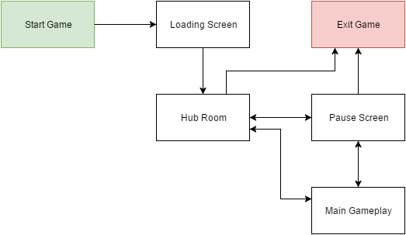

Player Cannon
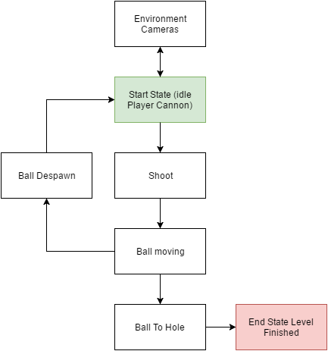

Basic Functionality:
Ball - Can be launched from cannon. Features multiple power-ups and has the ability to interact with specific objects. Utilizes Unity’s physics engine.

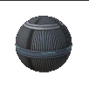

Cannon - This is the player it features a reticle on screen that indicates where the ball will be launched from. Around the reticle, there is a circle that indicates the power level of the shot based off of how long the player has held the left click button on the mouse pad.

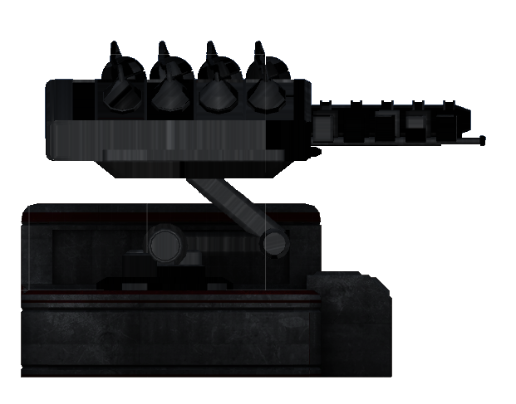

Environment Camera - These have the ability to switch between each other and allow for the user to have a better understanding of the levels. If the player hits one with the ball the camera will break and become inactive, this inactive state will display static.

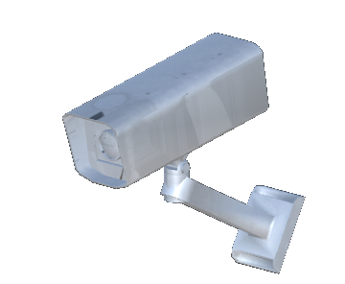

Black Hole - This is the goal state and features a gravity to drag the ball into itself and will warp the player to the next level in the sequence. Upon finishing a sequence of levels, the player will be warped back to the Hub World.

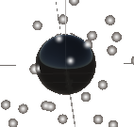

Controls:
Pause the game
Quit the game
Switch to environment camera
(In Environment Camera) Switch camera
Reset level
Return to hub world
Use mouse to aim
Hold left mouse button to charge shot
Release left mouse button to shoot

User Interface
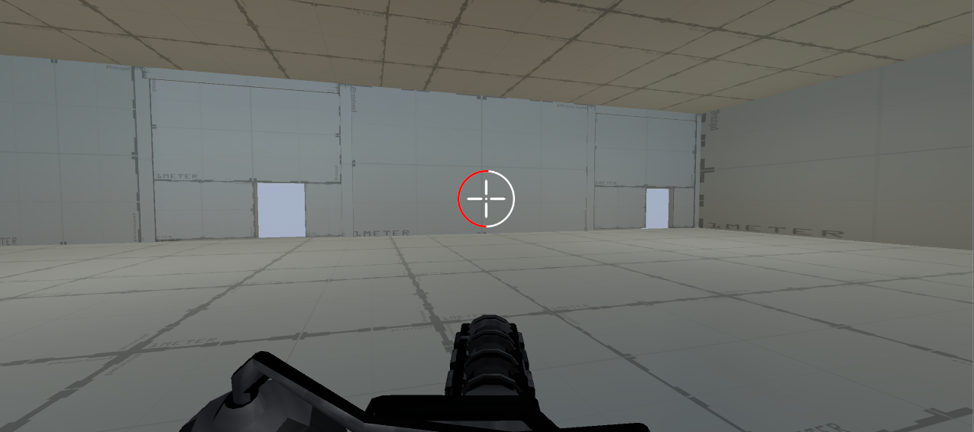

Player Cannon Shot Power:
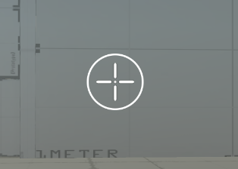
This gauge starts at the bottom of the circle and fills it red in a clockwise fashion. The player can determine how ‘hard’ their shot is going to be based on how much of the circle is red. This also acts as the aiming mechanism for the player.

Broken Environment Camera:
Displayed to the player when they switch an environment camera that is broken. In order for a camera to be ‘broken’ the player will have to hit the camera with their ball. If the player’s ball collides with a camera and then they switch to that specific camera’s view, it will display the image above.

Puzzle Elements:
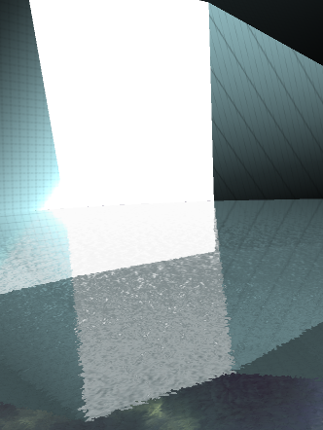 Water
Breakable Blocks

Switches
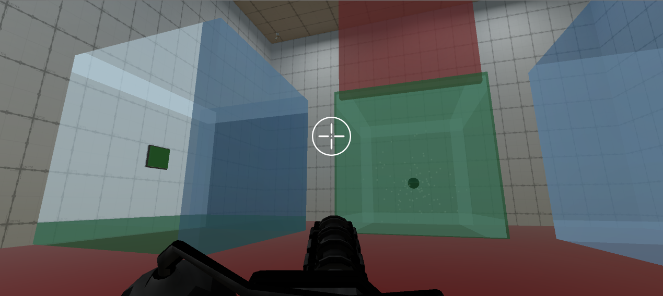Colored Doors
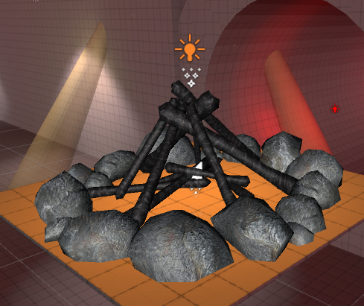Bonfire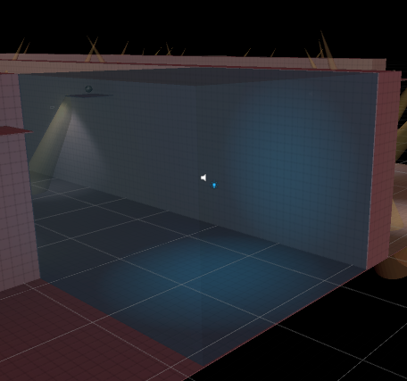Ice Block
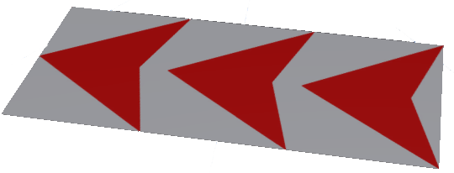Accelerator Pads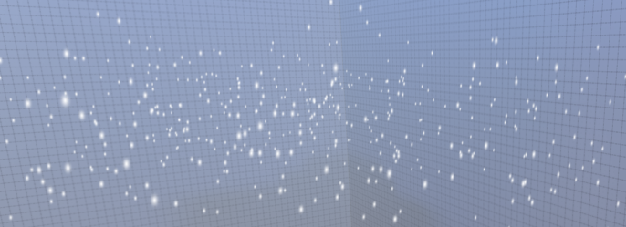 Gravity Fields
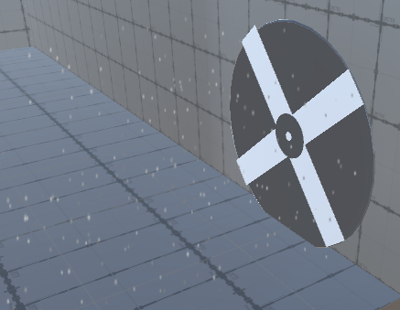 Fans
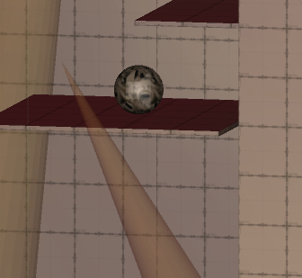Spotlights and Enemy

Schedule:
Completed by Timebox 5
Main Menu - 4 hours
Additional Levels - 20 hours
Enhanced Features - 10 hours
Polishing and Bug Fixing - 5 hours
Enhanced Levels - 10 hours
Completed by Timebox 6 (Tentative)
Scoring System - 2 hours
Poster Creation - 4 hours
Testing and Bug Fixing - 10 hours
Additional Levels - 15 hours
Enhanced Levels - 15 hours

Bibliography
Unity3D.com
CSE 5912

