Mine the Gap
Instructions
David Householder
Michael McCarrick
Geoff McGinnis
Will Ruck
Erik Schilling
4/17/2014

Contents
Introduction 1
Getting Started 2
Controls 3
Placing Buildings 3
Controlling Units 6
Camera Control 7
Maze and Anomalies 8
Hotkeys 8
Known Bugs 9

Introduction
Mine the Gap is the marriage of several concepts that are near and dear to our hearts: real-time strategy, Minesweeper, and space! Starting with a single capital ship and few resources, you will need to mine, build, solve and destroy to outsmart your opponent. The ultimate goal is the destruction of the opponent’s capital ship, located somewhere else in the maze of asteroids, mines and spatial anomalies.
To accomplish this goal, unique units and buildings can be constructed, each with their own benefits and weaknesses
While buildings provide a certain amount of resource generation over time, larger bounties are available to those who explore and brave the dangers of the solar system. Planets hidden in the maze provide vast resources to those who find them. Planets also provide a strategic point to launch your next exploration or daring attack
Space is a dangerous place at the best of times, and this area of it is of a particularly menacing nature. Mines of various types will tear your ships to shreds in a heartbeat if you do not learn from your mistakes and either mark them or extract them to use on your enemy. While mines are a constant danger, spatial anomalies are not part of a logical universe. Be wary of unidentified objects, creatures, and formations that lurk in the darkness of space, for they are not always as they appear.

Mine! Build! Solve! Destroy!
But above all else: Mine the Gap!

Getting Started
Upon starting up the game you will be presented with a menu screen as shown below in figure 1. Selecting Multiplayer from this menu will take you to figure 2 where you can either setup or host a game.
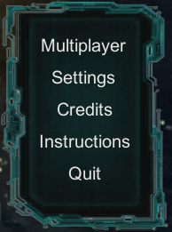
Figure 1: The main menu to play the game.
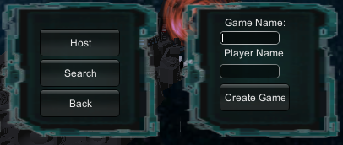
Figure 2: The multiplayer menu with the host button already selected. Select search if someone else is hosting.
Whether you choose to host or search for a game, you will be prompted with a name. The name you enter must be at least for characters long. Next, if you're hosting (after pressing 'Create Game') you can specify the different map conditions with the sliders in the upper left corner as seen in figure 3.

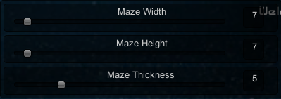
Figure 3: The host's view of the option sliders.
Here we see three options: Maze Width, Maze Height, and Maze Thickness. Maze width and height will determine the overall size of the maze and its dimensions. In figure 3 width and height will produce a square maze that is 7x7. The maze thickness determines how big the blocks are in unity units. In this setup a thickness of 5 means that a 5x5 square is considered one block which will be used for generating the maze. In total, the maze this will generate will be a 35x35 size grid with walls and hallways at least 5x5 long. Larger maze thicknesses will create longer distances between waypoints. Since you only have five minutes, it is suggested to use the settings above if you're hosting the game.
In order to start the game, the players in the lobby both must press the ready button in the bottom middle of their screen. This will allow the host to then press a new start button that will appear below his or her ready button. Pressing this will initiate game loading for both players.

Controls

Placing Buildings
At this point you should be in the game with your camera focused on a ship (Figure 4). This ship is what you must protect at all costs and destroy the enemies version at all costs.
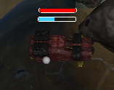
Figure 4: The main base of either player. Its health is represented with the bar on top, and its production completion % is represented by the bar on bottom. You need to defend yours and destroy the enemies.
You may only build around this ship. When building, a green circle will appear to let you know where you can build. If the maze were big enough, there would be a higher chance for planets to appear in the maze, which you could capture and build around as well; however, with the settings above, the map will be very small and not likely to occur.
You should also see some GUI stuff on the right side of the screen, seen in figure 5. This GUI is broken up into three distinct parts. The stats, building, and info area.
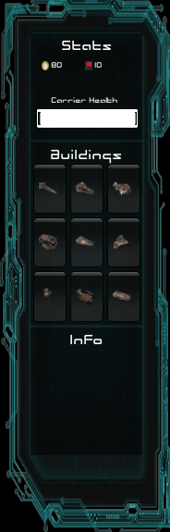
The stats area shows the amount of money (yellow icon), how many flags you have left (red icon), and your main bases health at all times.
The buildings area contains 9 buttons that you can press. Pressing the button will allow you to place buildings once your mouse is back near your carrier.
The info area will be useful later when selecting units. It will show several icons if many units are selected, or the stats of the item selected.
Figure 5: The GUI and controls for the game. Broken up into three parts. The middle part will be used for building.
The buildings area is currently what is important. These buttons are what you will press in order to place buildings near your carrier. Simply press a button and move your mouse back over to your carrier. If you have enough money you will be able to place the building, if not, you will be clicking mindlessly and will need to right click to cancel the build. Currently we do not have prices on mouse hover, so you will need to refer to the handy dandy table in figure 6, which shows the prices of each button by location.

30 | 50 | 100
125 | 150 | 150
150 | 175 | 200
Figure 6: A table relating the price to button location.
As you can see, you'll be mostly spamming the top left button, which based on balancing right now, is really what you should do whether or not you had the money from a very long game (with the exception of the unit that costs 175).
When placing a building you may notice it changes between red and green. If the building that is following your cursor when placing turns red, then something is in the way and you should move your mouse. If it turns green then you can place the building.
Buildings have two bars (regular units will only have one), which can be seen in figure 7. The top bar shows the percent of health that building has left. As it takes damage it will go down and eventually the building will be destroyed. The bottom bar shows the progress on unit production. Early game units take 20 seconds to build. This bar effectively shows you the percentage of time that has already been accomplished in the build. When the bar becomes full, a new unit will pop out, at which point the bar will reset to empty and begin to fill again.
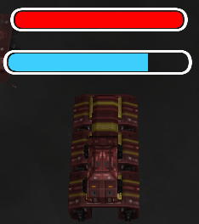
The health bar, showing off the full health of this building.
The production bar, indicating a unit is almost finished being produced.
Figure 7: A factory producing units with a full health bar (top), and a nearly complete unit (shown by the bottom bar).

Controlling Units
Now that you have created some buildings, units will begin to be produced. As units are created you will notice you have no direct control. The will wander the map aimlessly heading towards little dots that are everywhere.
Each of these dots, which can be seen in figure 8, can be used to control the general direction of a unit.
Click here.
Drag to here.
Figure 8: A dot on the map.
To control a unit, click and drag such that the dot is selected, similar to how you would select several files. If you were successful in selecting the dot (waypoint marker), you should end up with something similar to figure 9.
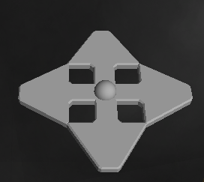
Shift click here.
Then click off of it.
Figure 9: An expanded waypoint with directions ready to be selected.
By now, the waypoint should be expanded showing four arrows. These arrows dictate which direction a unit will travel. To select a direction shift+click one of the arrows. This will cause it to turn green, indicating the selection was successful. Next, click away from the waypoint to deselect it (you need to deselect before changing directions again).
Once you have clicked off the waypoint, it should resemble figure 10, which shows a single arrow selected (you must do this before you can change the direction again). Congratulations, units will now travel in this direction.
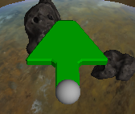
Figure 10: A waypoint with its direction set.

Camera Control
You have several ways to navigate around the map. First of all, you can press your mouse against the edge of the screen. This will begin scrolling the camera in that direction. Next, you can use the W,A,S,D or arrow keys to move the camera. This method will move the camera slightly faster. Lastly, you can directly click on the Minimap in the bottom left corner. This will center the camera in the Minimap's location. This will get you to where you want to be very quickly.

Maze and Anomalies
While playing the game you may notice some of your ships are dying unexpectedly, or getting sucked into dark swirly things. This probably means there is a spatial anomaly there. These are scattered around the map and can be very devastating and this is where the flags and flag counter come in.
As you'll notice on your GUI, there's a little flag icon with a number next to it. This is how many flags you have, which is how many anomalies you can still turn off. Turning off anomalies will disable the effects for both you and your opponent.
To flag an anomaly and disable it:
1. Locate the anomaly. This is simple for black holes (the swirly thing that sucks in your ships), but much more difficult for mines, which will just kill your ships randomly.
2. Right click on the area (with no building selected) that you believe to be an anomaly. If you were successful in locating the anomaly, it will be disabled, if not, go to step 3.
3. Right click on the flag once more to recover it. If you had successfully disabled an anomaly with this flag, and there are no other flags marking the anomaly (for both you and your opponent) the anomaly will activate again (which may be useful to keep in your back pocket).
When placing a flag your flag counter will decrease (see figure 5 in the stats window). Once you run out, you will need to right click old flags to recover them (step 3), or sit there idly hoping that you do not need more. Figure 11 shows what a flag marker looks like.
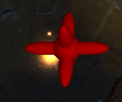
Figure 11: A 'flag' used to disable anomalies. If it is close enough to an anomaly, the anomaly will disable. Right click again to retrieve it.

Hotkeys
left ctrl - Toggles health bars.
c - Focuses on your carrier.
f - Focuses on selected unit (if only one is selected - hold to use).
escape - Resets selected building timers to 0.
backspace - Destroys selected buildings (no refunds!).

Known Bugs
-Minimap becomes bright when unit travel far away from base
-Unit movement twitchy & health sporadically changes (player 2)
----To fix unit twitching, make sure waypoints have directions assigned, otherwise the server/client think units are going in opposite directions
-Missiles not firing (player 2)
-Sometimes no explosions on mines (player 2)
--Mines in general may be unfriendly during game play
-No way to quit without losing/winning
-Waypoints are a pain to click

