Spellements

Design Document

Alexander Perry
Shawn Lee
Richard Georgeoff
Brian Orchosky
Mehul Azad
Eric Mathews

Index

Introduction
FAQ
Game State Diagram
Starting Your Journey
Start Menu
Controls
HUD
Tutorial
Combat
Death
Winning the Game
Game Modes
Single Player
Multiplayer
Player
World Map
Navigating the Map
Node Types
Combat Arenas
Terrain Generation
Arena Types
Exiting the Arena
Spells and Runes
Runes
Enemies
Spider
Egg Sack
Skeleton
Golem
Demon
Boss Level
The Arena
Lord Wycliff
The Fight
Saving and Loading
Saving
Loading
Issue Log
Credits
Models
Music & Sounds
Images
Technology
Thank You

Introduction

Spellements is an arena based Roguelike (http://en.wikipedia.org/wiki/Roguelike) that focuses on using a highly customizable magic system to defeat enemies and progress through the game. Spells are created by combining magical “Runes”. The runes that drop and the levels that you play through are all random, so every play through will be a new experience!
In addition, you can play through Spellements with a friend, working together to overcome hordes of monsters. Many kinds of spells truly excel in this mode, where players can choose different roles in the party and tailor their spell selection to help them support their friends.

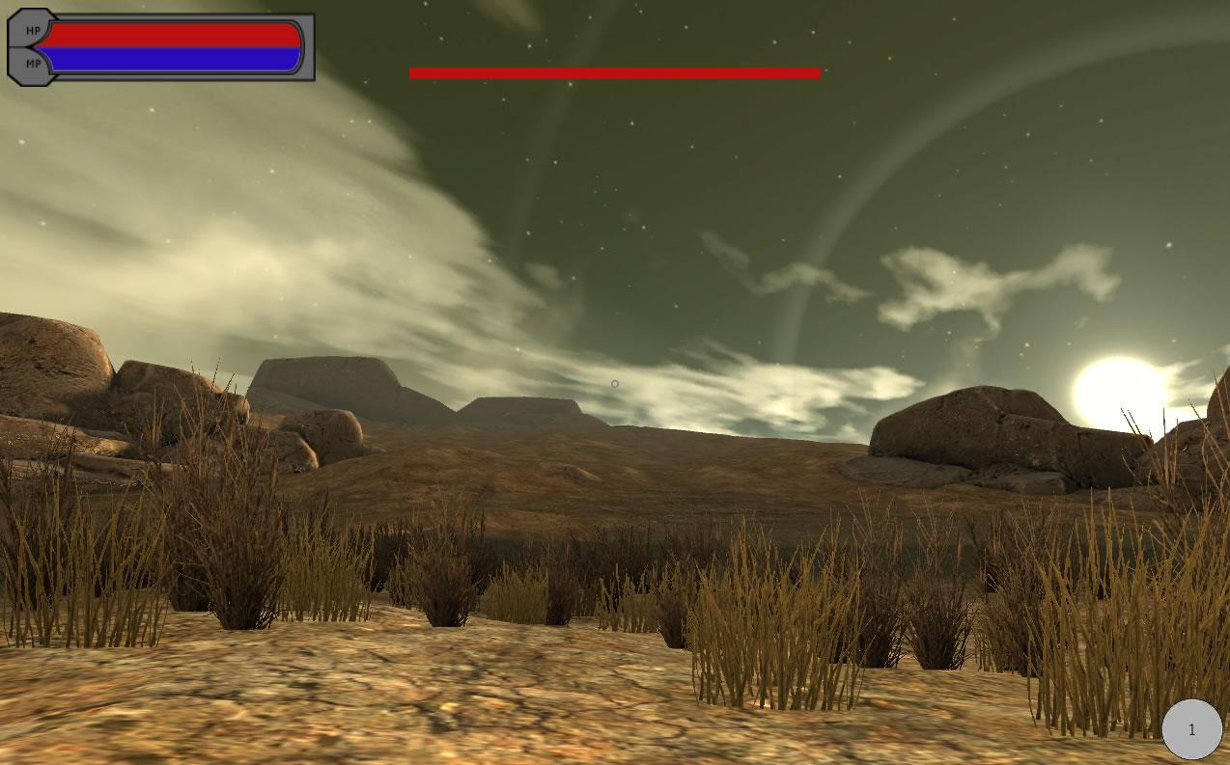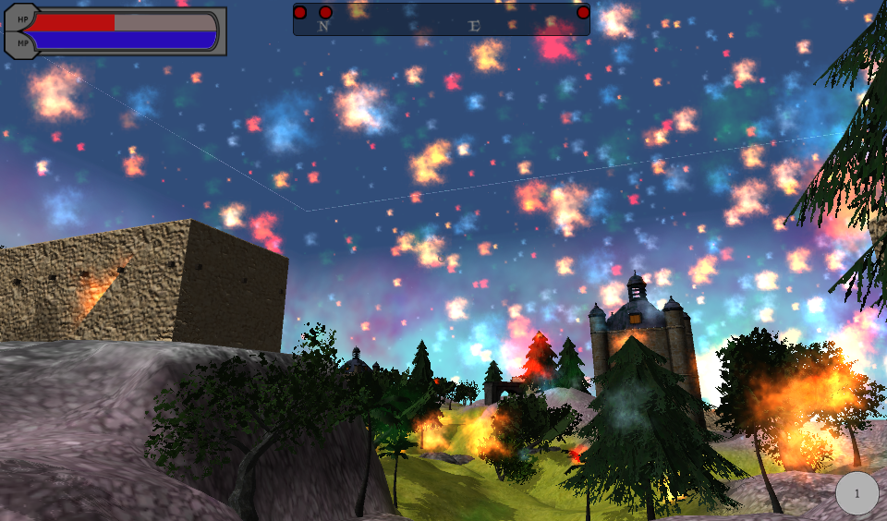

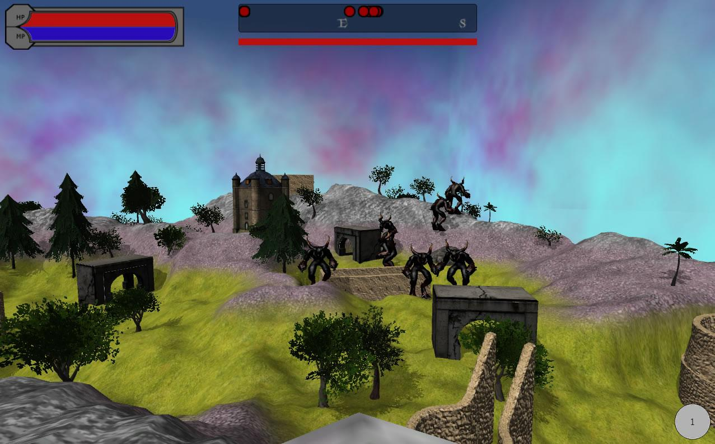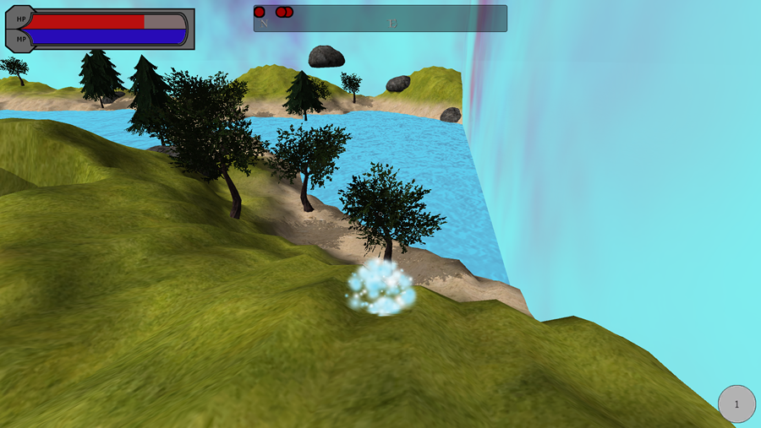

FAQ

I keep dying, what can I do to survive longer?
Spellements is a Rougelike game, meaning it is supposed to be punishing to inexperienced players. Making sure to make a Healing-Self spell is a good start. Also try to avoid attracting large packs of enemies, instead picking them off one by one.

I can’t click a node on the map after the tutorial!
Make sure you have completed the spell editor section of the tutorial by clicking the spell editor button in the bottom left corner of the screen.

Help! I got stuck when trying to choose my runes in the tutorial.
The tutorial is designed to allow the player to pick up only one set of two runes. If you have made a wrong decision, start a new game and select the runes you wanted.

I think I have enough runes and I want to see the next level. Is there any way to skip to it?
You can go back to the map by moving to the magical clouds at the boundary of the terrain. Press Enter when -” Press Enter to continue travelling” command pops up at the bottom of the screen.

The boss is too hard! How can I defeat him?
If you are having trouble with the boss, examine your playstyle. Rushing through the levels without defeating enemies and collecting enough runes will leave you very vulnerable against Lord Wycliff. Creating long-range spells will also help.

I keep running out of mana.
Every rune you place on a spell increases its mana cost. Try to decrease the number of runes on your spells by removing less useful runes. Try to manage your casting habits and improve your aim as well.

Where did the spiders go?
Spellements’ enemy spawning is set up in tiers, so the farther you progress down the map, the more powerful the enemies that spawn. Spiders are one of the weaker classes of enemies so they are replaced with stronger enemies later in the game.

Game State Diagram

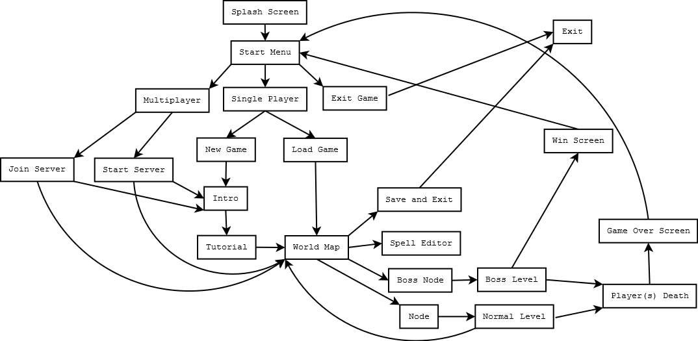

Starting Your Journey

Start Menu
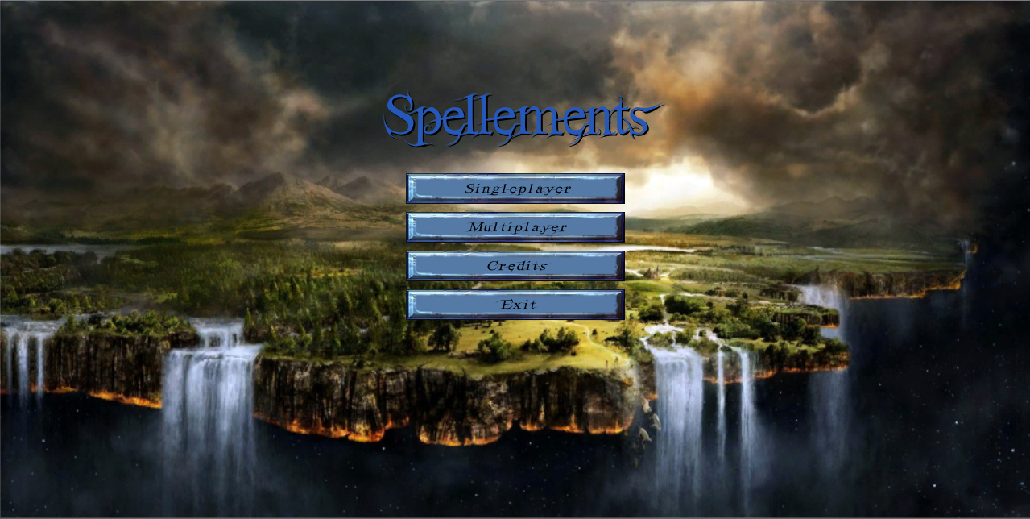
From the start menu, the player is given a few options:

Singleplayer: Start a new or previously saved single player game.
New Game: Begin a new journey
Load Game: Load a previously saved game
Back: Return to the main menu
Mutliplayer: Join or Host a multiplayer game
Host Server: Be the host for a multiplayer game
Join Server: Join a hosted multiplayer game
Back: Return to main menu
Credits: Nothing as of now, remains for future functionality
Exit: Close game

Controls

Spellements is played using a mouse and keyboard. The controls are listed below:

W (or up arrow) – Moves forward
A (or left arrow) – Moves left
S (or down arrow) – Moves backward
D (or right arrow) – Moves right
Spacebar - Jump
Numbers 1-6 – Selects active spell
Esc – Pause game to menu
Enter - Leave Map (Only when prompted)
Ctrl - Free cursor (not recommended)
Mouse Left Click – Cast current spell
Move Mouse - Aim

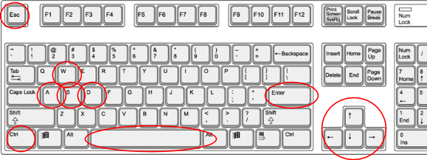
http://www.gcclc.org/StudentFiles/Mouse-Keyboard/Required/KeyBoard/images/keyboard4.png

HUD
The HUD (Heads-up Display) displays relevant information for the player during their battles against the armies of Lord Wycliff.
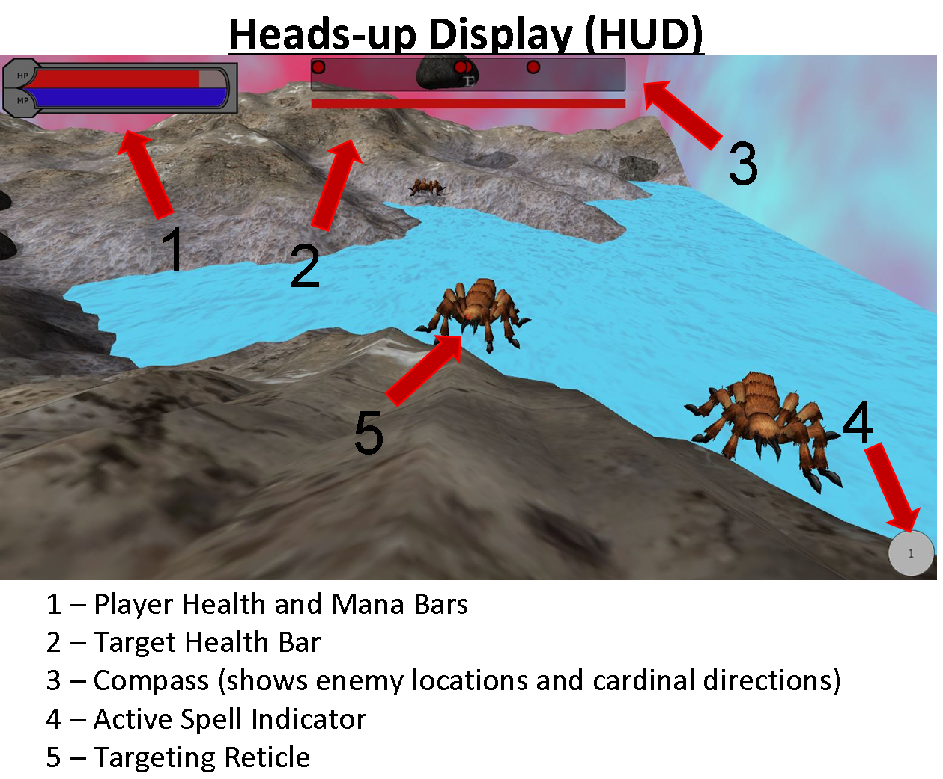
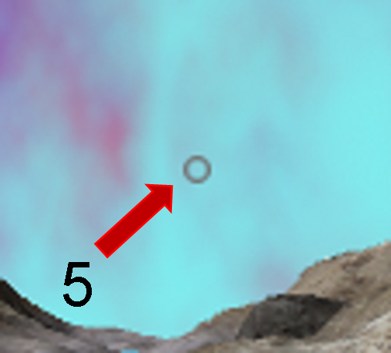

Tutorial
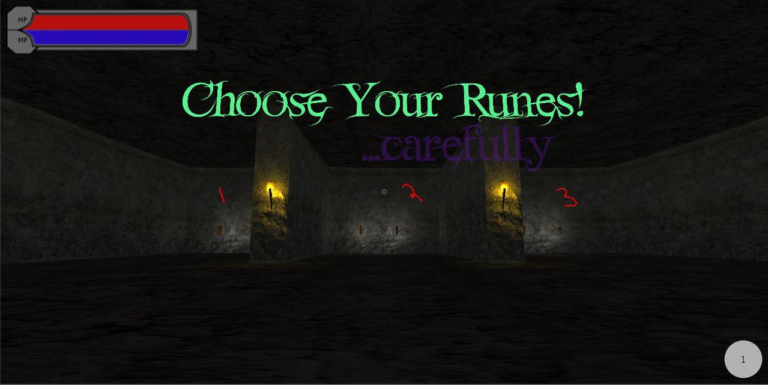
The Tutorial places the player in the Rune Armory of the Guardians and allows them to choose from three sets of two runes to create their first spell and start their journey. The player will become acquainted with movement and aiming, as well as collecting runes and spell crafting. The possible choices are as follows:

1 - Fire & Blast Rune
2 - Ice & Cone Rune
3 - Poison & Wall Rune

Following completing the tutorial, the player will be sent to the World Map where they will need to create their first spell by selecting the spell editor button and placing the two selected runes into the same spell slot.

Combat
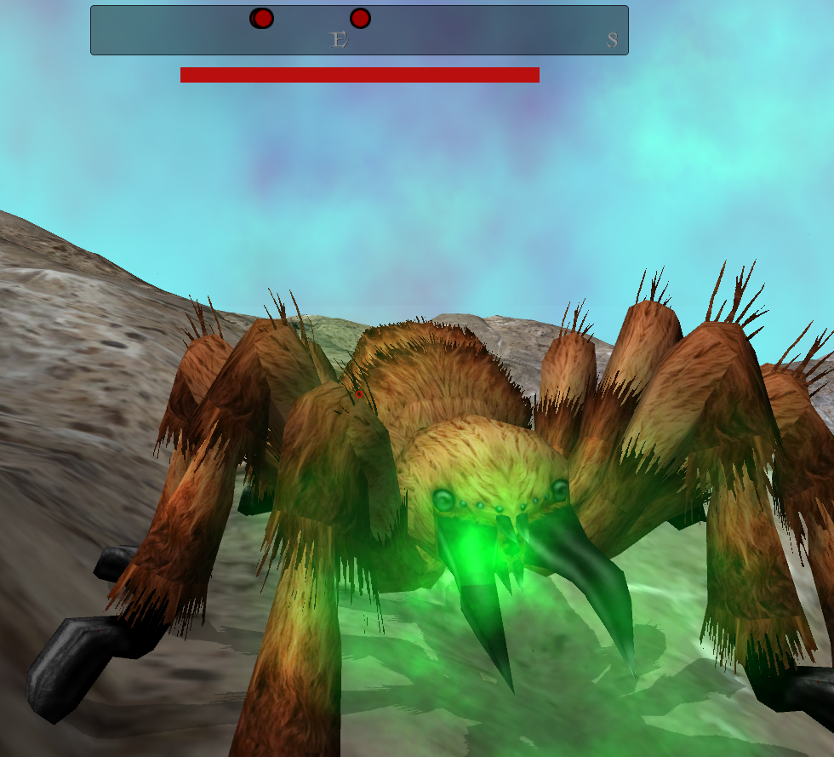
Once a player enters an arena, they will be able to enter combat with Lord Wycliff’s minions. Combat is achieved in a traditional First Person Shooter point-and-click style. Aim the reticle at the desired location with the mouse and left click to fire your currently equipped spell. The goal of combat is to reduce your enemies to 0 health by hitting them with spells, while keeping your health as high as possible by avoiding enemy spells. When an enemy is defeated they will die and disappear, sometimes leaving behind a rune for the player to collect.

Death

If, during a level, all players’ health reach zero the game will end and you will have to begin your journey anew.

Winning the Game
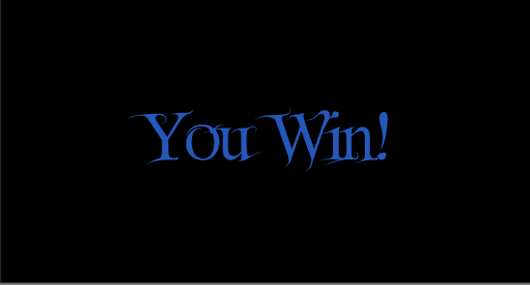

The game is won by journeying across the map and defeating Lord Wycliff in the final boss level.

Game Modes
Gameplay in Spellements can be experienced in two ways: on you own or with a group of friends. The two modes will require you to create different strategies to survive.

Single Player
The standard mode of play. Traverse the world on your own, defeating all the abominations of magic that stand in your way and ultimately Lord Wycliff himself.
Upon selecting a new game, you will be placed in the tutorial level where you can choose the two runes you will start with. Upon collecting the two runes, you will go to the world map screen where you can then craft your first spell. You will be prompted to visit the spell editor to do so.
After you have your first spell, you are ready to select a level from the world map. World maps are randomly generated, so you may have multiple levels to choose from. Which one you choose is completely up to you, although it is recommended that you choose a sufficiently lengthy path to the boss in order to build up your rune supply, as collecting runes both powers up your spells when applied but also increases your max HP and MP stats.
When a level starts, you will be dropped in a combat arena, a place in the world enclosed by magic barriers. You will find multiple enemies in each arena - use the compass located at the top of the screen to track the direction each can be found in. When each enemy is defeated, there is a high chance a rune will be dropped. Collect it, and the rune will be available for use in the spell editor after the level is complete. To get the option to exit the level, either defeat all the enemies in it or travel to one of the magical walls. At the end of each level, you will be able to reform your spells in the spell editor. Saving is automatically handled whenever you exit the spell editor, start a level, or collect runes.
You can play levels in any order you wish until you reach Lord Wycliff. Successfully beating him will trigger the ‘You Win’ screen.
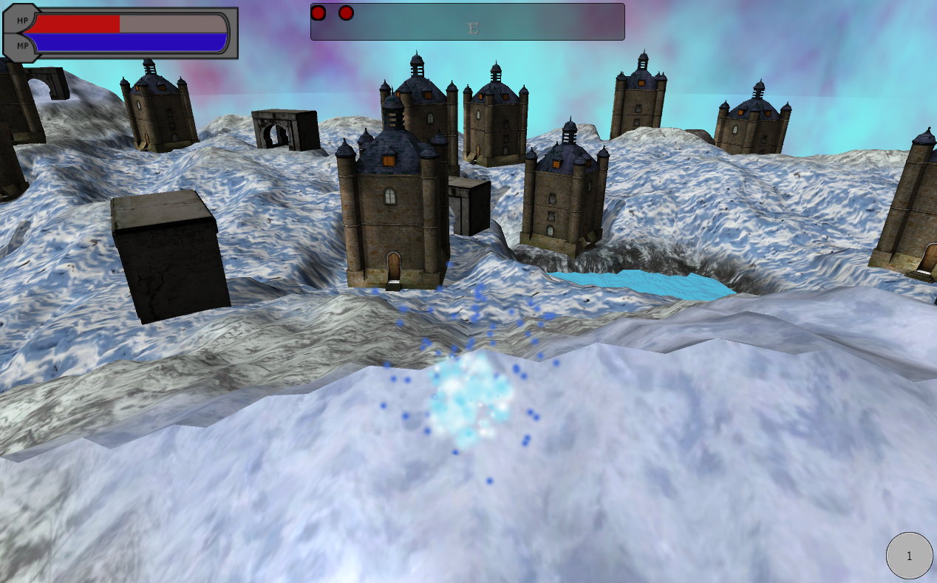
If you should fail before reaching that point and lose all your HP in a given area, your save file will automatically be destroyed when you reach the ‘Game Over’ screen. From that point, you’ll have to start the game anew with zero runes and a new world map.

Protect the realm!

Multiplayer
Cooperative play for up to four players. Traverse the world with one, two, or three friendly faeries and coordinate your spells to help each other and defeat your enemies.
The server will select ‘Create Server’ on the main menu. You will have to take note of your IP address and the port number you use, because all other players will need those to join your game when they select ‘Join Server’. When the server has created a server, they will also choose whether to play a new game or a saved game. If they choose a new game, they will be warned to wait for all other players before advancing through the tutorial level. The server will only have the option to complete the tutorial level once all connected players have finished it.
Once the server leaves the level, all players will go to the world map. The game proceeds as it does within single player with a few key differences. First, there is a chat function so that players can exchange short messages with each other, as well as be updated on certain actions in the game world. This option exists on the map screen, the spell editor, and in combat arenas (via the escape menu).
In the world map, the server is the only one able to choose a stage. They may only do so if nobody is in the process of editing their spells.
Just like in the tutorial stage, only the server is able to exit the combat arenas through either elimination of all the enemies or coming close to the magic barriers at the level edges. Once the server leaves, everybody will exit the level at the same time.
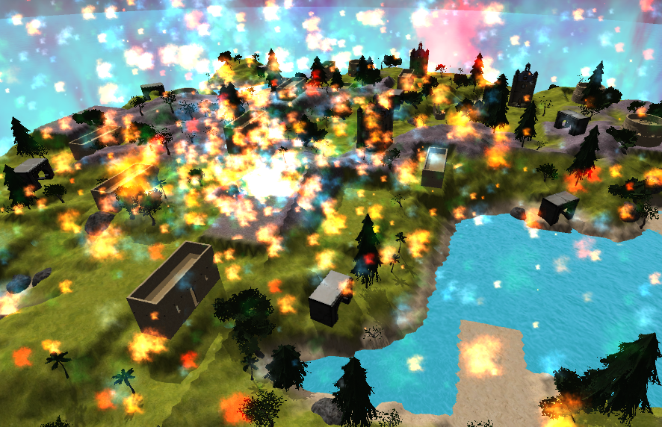
Finally, in multiplayer it is essential to remember that spells will hit anyone in their path, friend or foe. Thus it is important to control your spells so that they don’t hit unintended targets. You may also find certain spells becoming very useful - for instance, one person can be designated as a healer and buff the entire party with a single spell before charging into battle. Or four players can bombard a group of enemies with a cavalcade of long-range spells from atop a mountain - the possibilities are many!

Mankind’s careless use of magic… this would probably hurt your friends just as much as your foes!

Player
As one of the few guardian faeries left standing, you are tasked with defeating the armies of the evil Lord Wycliff and closing the magic rift. Collect runes to increase your stats:

Health Points: This is the survivability stat, the more HP the player has, the more spell damage they can sustain from enemies before dying.
Magic Points: Mana Points are expended each time the player casts a spell. The higher the number of runes attached to a spell, the more the spell will cost to cast.
MP Regen: Magic Points will regenerate over time based on this stat.

World Map
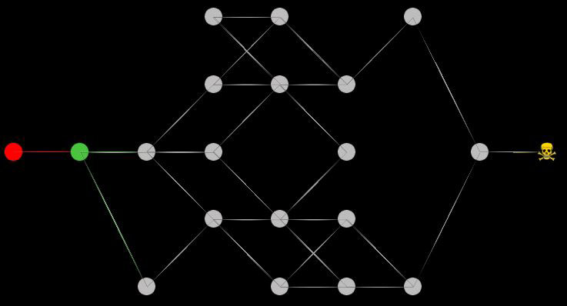
Each new game has a new, procedurally generated world map that can have anywhere between 14 to 22 playable levels. The player will return to this screen after each level to decide where next to go.

Navigating the Map

The node that the player is currently at is indicated by a red circle. Each node has a series of connections that represent where the player can go from there. The first node is the tutorial level that the player starts on and is connected only to the second node. The second node acts as a hub for the majority of the map and is connected to every node in the next column. For each subsequent row until the second to last node, the nodes are connected only to nodes that are not in the same column, are no more than one column away and are no more than one row away. The second to last node also acts as a hub to prepare the player for the boss level and is connected to every node in the previous column. Finally, the final node is the boss level. The player is also capable of returning to a node that has previously been visited.

Node Types

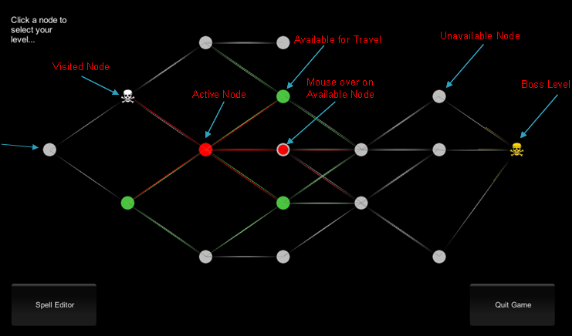

Active Node - This is the level that the player has just finished playing
Unavailable Node - The player has not yet reached this node
Available for Travel - The active node has a connection to this node
Visited Node - The player has previously traveled to this node
Boss Node - This is the level where the final boss may be found

Combat Arenas

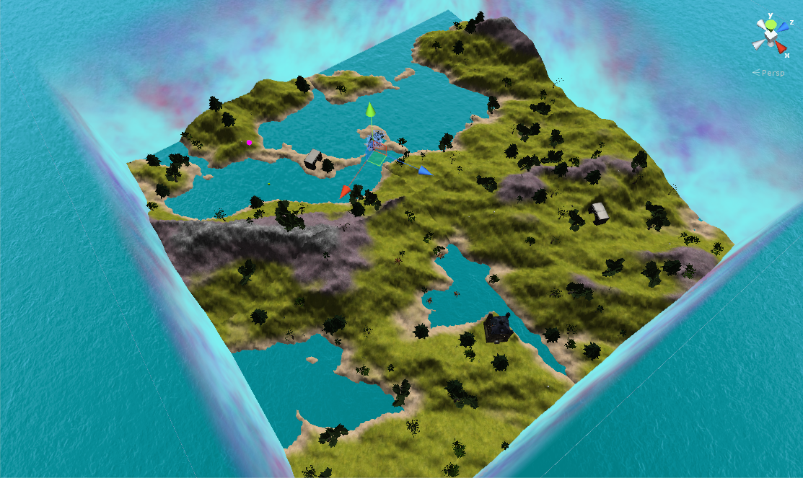

Terrain Generation
Each level is randomly generated to ensure a different and unique arena each time the user plays the game. It also places structures all over the battlefield that can be used as cover, and some structures the player can enter into and bunker-up, allowing for various play styles. Trees, and various flora can be knocked down by both enemies, and the players spells. This is convenient if the player is trying to make a hasty getaway but there are trees in the way. Use a spell and the player can blast their way through.

Arena Types
There are various themes that the generator creates. Themes are very easy to expand upon so players could expect many different themes and structures in the future. As of now there is a normal terrain, fire/desert terrain, and ice/rocky terrain. The different terrains have specific types of buildings and other aesthetics. The player should plan ahead and adjust their spells accordingly.

Exiting the Arena
There are three possible ways to exit the arena:

Defeat all Enemies: When all enemies in the arena are defeated, a message will display and the player will be able to press enter to continue traveling.
Edge of Map: If a player runs to the edge of the arena they will be able to leave by pressing Enter when the message is displayed, regardless of the number of monsters defeated (not recommended).
Death: If the player is defeated they will be returned to the main menu and be required to start a new game.

Spells and Runes

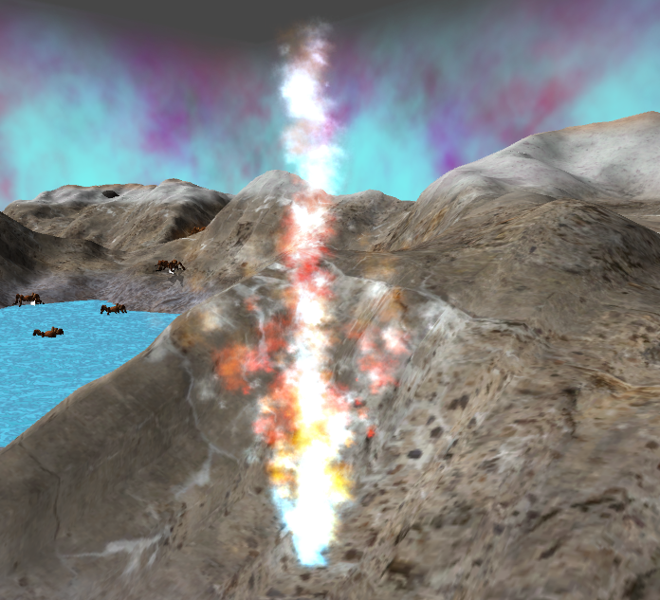

Spells are the players’ main resource to combat the enemies of the world. These spells are crafted by combining runes in the spell editor.

Runes

Runes are the magical elements which a spell is made up of. They are grouped into four types:

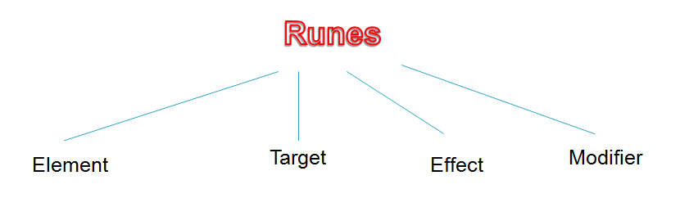

To begin, a player is given one spell which is made up of two runes. He or she can only choose one rune pair out of the three given options:

- Fire and Blast (Left)
- Ice and Cone (Center)
- Poison and Wall (Right)

As the game progresses, try to collect as many runes as possible. Runes are only dropped when enemies are killed. The runes that can be encountered during the game are:

Type : Element
- Used to directly deal damage and color a spell.
- Can combine with other runes such as Resistance, in which case it does not deal damage.
- The elements are mechanically the same, but enemies may use and resist certain elements.

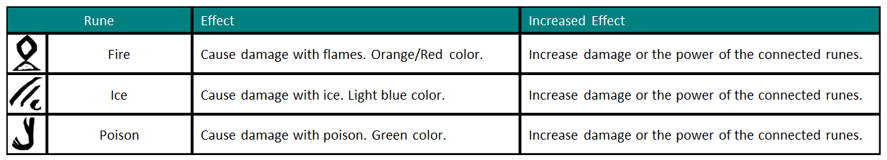

Type : Target
- Defines the behaviour of a spell when cast.

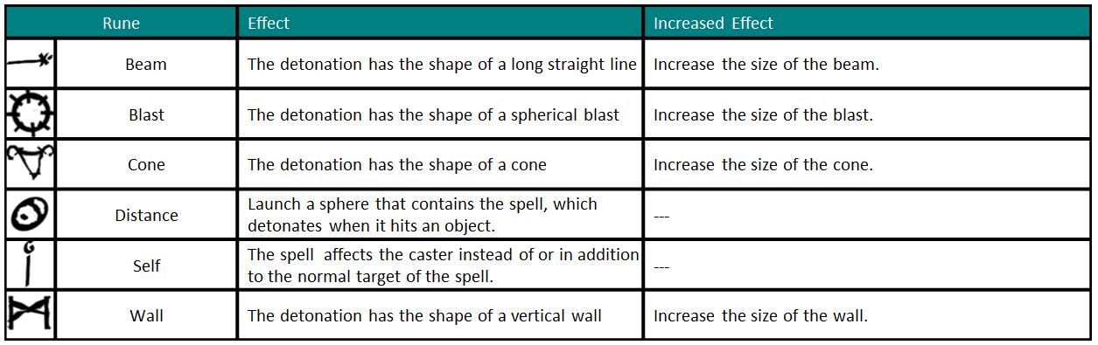

Type : Special Effect
- Provide additional effects when a spell hits a target
- Includes both beneficial and harmful effects

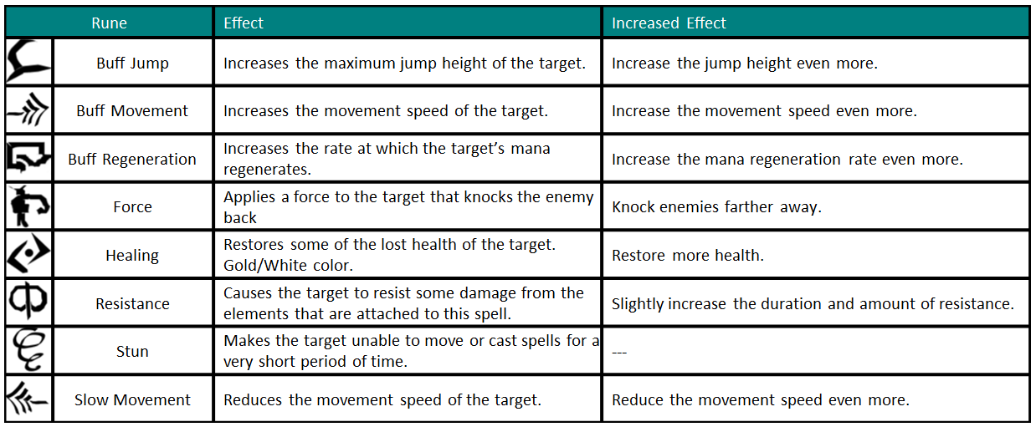

Type : Modifiers
Change the behavior of the after it detonates.
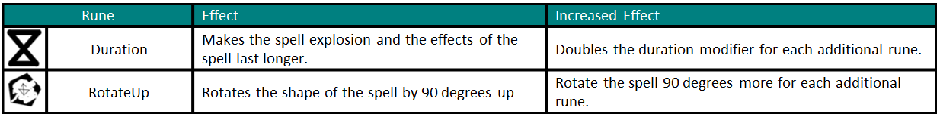

Spell Editor

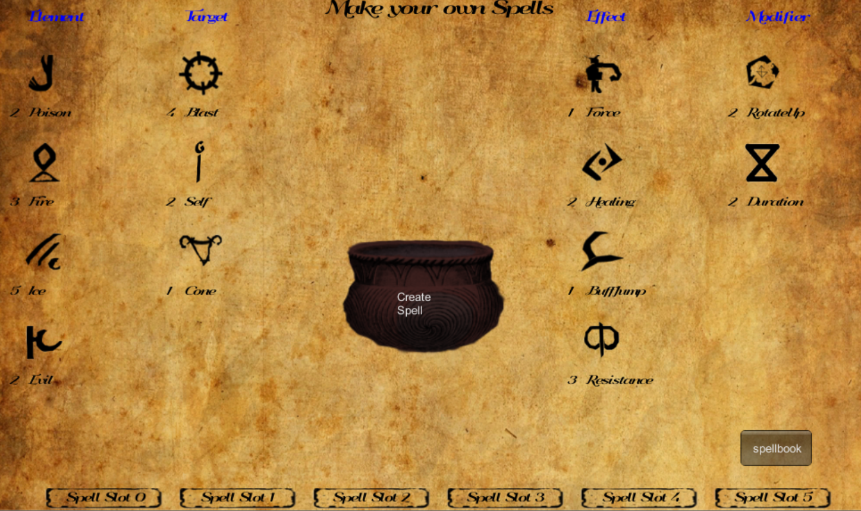

The intensity and power of spell can be increased and decreased as needed. This is accomplished by increasing the number of runes in a spell using the Spell Editor.
For example, for a high damage fire spell, instead of using just 1 fire rune, use 2 (or more!) runes to increase the damage. If you want to cast a bigger blast, increase the number of blast runes in the spell.

Using the Spell Editor

The Spell Editor is accessed through the World Map screen by selecting the button labeled as such. In the Spell Editor the player will see all available, unused runes on the left side (with numbers marking the quantity). To create a spell, select the desired spell slot and select the desired runes from those available to place into the spell. These spells will be automatically saved into your spellbook and ready to use once you start a level.

Enemies

Many dangerous enemies inhabit the corrupted world. You will need to defeat these enemies and collect the runes they drop in order to prepare yourself for the final showdown with Lord Wycliff.

Spider
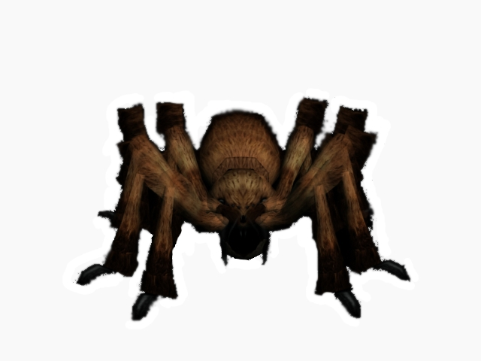
A corrupted native species of the world. They are aggressive enemies that, although weak individually, will swarm an inexperienced player. They are known for their high speed charges and poison breath. Some spiders may even release excess poison after death!

Spell | Runes | Effect
Poison Breath | Poison, Cone | Damage Player
Charge | N/A | Movement Speed x2

Egg Sack
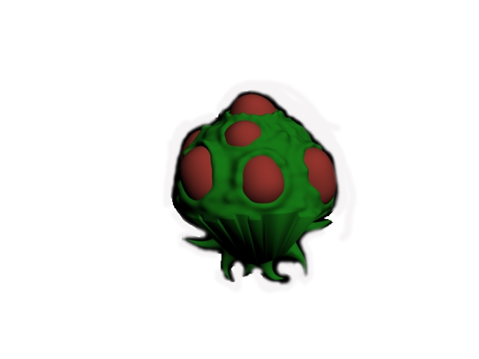
Despite their name, these creatures were once beautiful plants, however pockets of magic have found their way into the flora of the world. These enemies will explode when the player gets too close, catching unattentive players in their poison blast for massive damage.

Spell | Runes | Effect
Explosion | Poison, Blast, Duration | High damage, persistent poison cloud

Skeleton
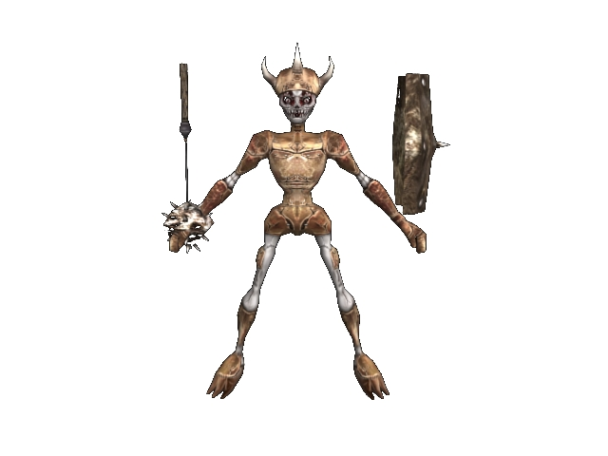
Ancient sages risen from the dead by Lord Wycliff’s necromancy, these enemies heal their wounded allies. They have also developed an affinity to evil magic, which they are more than willing to use to damage the player from a distance.

Spell | Runes | Effect
Healing Blast | Healing, Blast, Distance | Heals Ally
Heal Self | Healing, Self | Heals Self
Evil Blast | Evil, Blast, Distance | Damage Player

Golem
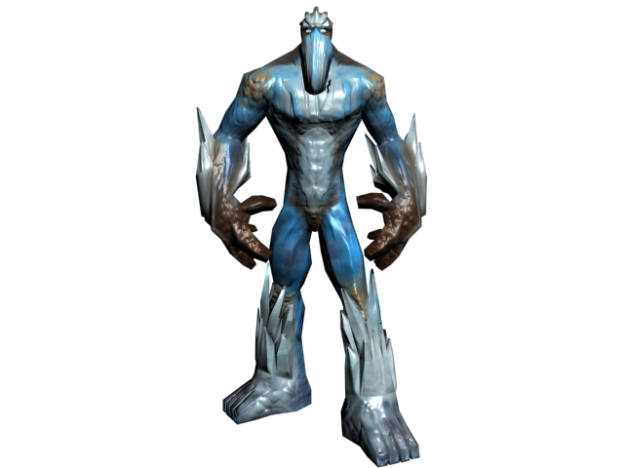
The golems are a hardy race that has been corrupted by their careless experimentation with ice magic. They are excellent spellcasters who prefer to bombard the player from a distance. They are also quite capable close range fighters using cones of ice that chill the bones.

Spell | Runes | Effect
Ice Ball | Ice, Blast, Distance | Damages Player
Cone of Cold | Ice, Cone | Damages Player (long range, low damage)
Ice Breath | Ice, Cone | Damages Player (short range, high damage)

Demon
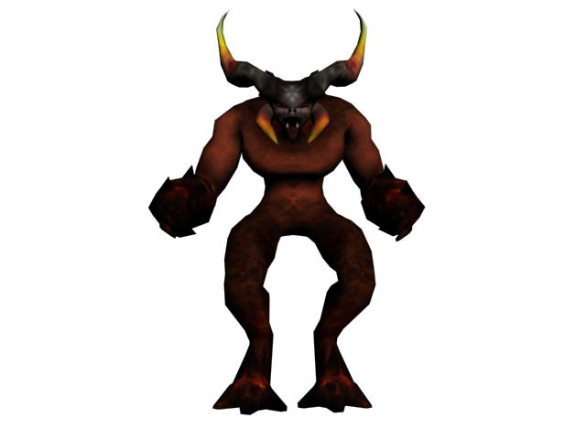
The elite troops of Lord Wycliff’s armies, they journeyed through the rift to assist with the destruction of the world. They are experts in the realm of fire magic. Watch out for the fire breath!

Spell | Runes | Effect
Fireball | Fire, Blast, Distance | Damages Player
Cone of Fire | Fire, Cone | Damages Player (long range, low damage)
Fire Breath | Fire, Cone | Damages Player (short range, high damage)

Boss Level

The Arena
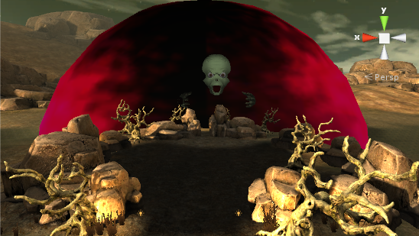
Lord Wycliff rests on the tattered plains outside the city. The arena is made up of a few important components:

The Rift - This is the rift that Lord Wycliff and his armies entered the world through. You must defeat Lord Wycliff to close the rift and save the world! Once you enter the rift the fight will begin and you will be unable to leave.
Healing Rain - Your fellow guardian faeries will occasionally drop healing spells through the rift, run through them to restore precious health.
And...

Lord Wycliff
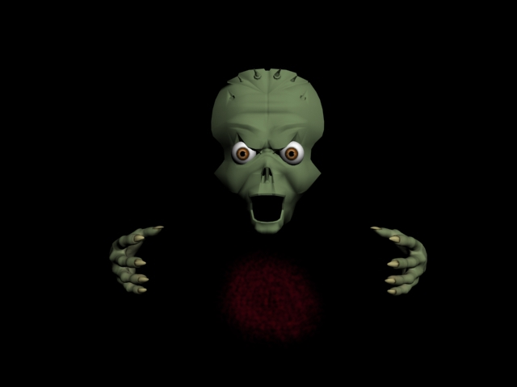
The evil behind the corrupted magic. Overloaded with the powerful evil magic element, this boss casts spells from five locations which must be independently killed:

Head - Weakest section, but protected by a magic barrier.
Eyes - Lasers and Nukes spells, watch out for the red eyes!
Left Hand - Healing and Minefields
Right Hand - Flame Blasts and Tornados

The Fight
Lord Wycliff has some tricks up his sleeve! This fight consists of four phases:

Phase One - Standard phase, attack Lord Wycliff!
Phase Two (75% HP) - Spider Spawn, Lord Wycliff invulnerable
Phase Three (50% HP) - Golem Spawn, Lord Wycliff invulnerable
Phase Four (Hands & Eyes defeated) - Berserk Phase, Head attackable

Saving and Loading

Saving
If you need to take a break during your quest, you may select the Save & Exit Button from the World Map screen to save your current progress. Note however, that if at any point you are defeated, your save file will be permanently erased!

Loading
If you have a previously saved game that you would like to continue, simply select Load Game from the Start Menu to continue your quest where you left off.

Issue Log

General Issues
-Second Run Through Issue: Sometimes when exiting a game and beginning anew, some strange errors occur such as:
Player being frozen in mid air
Player not being required to do spell editor tutorial
- Rune pickup text stacks
-Going to the pause menu does not unfreeze the cursor, making it impossible to exit from the pause menu (workaround > leave the map and exit from the World Map)
- There are reports of the force rune catapulting the caster forward without a self rune.
-Particle buff/debuff effects appear as columns underneath most enemies.
-In some Boss level scenarios, the Ice Golems/Spiders may disappear before being killed, this makes the boss level unfinishable as the boss remains invulnerable while they are still alive
- After the tutorial, some GUI text does not show up for the map (if in multiplayer, only happens for the server character)
- GUI text on map sometimes appears darker than it should.
- GUI text also disappears when returning from spell editor to map screen and loading a saved game.
- After loading a game, it will ask you to create a spell, even if you already have one.
- The text telling you to press enter to continue in a stage sometime doesn’t show.

Spell Editor Issues
-When the spell editor scene is run in sequence with other scenes, all the textures vanish. The buttons work but can’t be seen.
-When the spell editor scene is run individually, sometimes the textures disappear randomly. The workaround to that is removing and reattaching the scripts.

Multiplayer Issues
- After-death spider poison does not synch due to enemy not existing at that point. However, player HP will still be affected due to how game handles damage on the server side.
- When the server and clients have save files from different games, you will experience errors. When having a saved co-op game, always make sure that nobody else plays a different multiplayer game in the meantime, or the previous game will be overwritten.

Credits

Models
Spider- Kalamona (https://www.assetstore.unity3d.com/#/content/10104)
Skeleton - k.fantasy (https://www.assetstore.unity3d.com/#/content/7428)
Egg Sack - Danimal (http://opengameart.org/content/giant-egg-sack)
Golem - Andres Olivella (https://www.assetstore.unity3d.com/#/content/3746)
Demon - Andres Olivella (https://www.assetstore.unity3d.com/#/content/2971)
Lord Wycliff
Head - Storm 909 (http://www.turbosquid.com/FullPreview/Index.cfm/ID/391246)
Hands - 3dchars (http://www.turbosquid.com/FullPreview/Index.cfm/ID/702283)
Eyes - http://www.cgonlinetutorials.com (http://www.cgonlinetutorials.com/tutorials/3ds-max/modeling-eye-teeth-tongue/eye-texture.jpg)
Buildings - Unity Asset Store (https://www.assetstore.unity3d.com/‎)
Boss Level Terrain - geartechgames@me.com, (https://www.assetstore.unity3d.com/#/content/7075)

Music & Sounds
Spell Effects
Evil - mareproduction (http://www.freesound.org/people/mareproduction/sounds/187976/)
Ice - Ryding (http://www.freesound.org/people/Ryding/sounds/94352/)
Fire - qubodup (http://www.freesound.org/people/qubodup/sounds/159725/)
Poison - qubodup (http://www.freesound.org/people/qubodup/sounds/171255/)
Start Menu - SoundChris "Sons of Valhall" (http://www.newgrounds.com/audio/listen/547585)
Multiplayer Chat - LloydEvans09 (http://www.freesound.org/people/LloydEvans09/sounds/185828/)
Final Boss - Macleod, Kevin. “Black Vortex” (http://freemusicarchive.org/music/kevin_macleod/)
Splash Screen - "Fire Sound Effect 1" (http://www.soundjay.com/nature/sounds/fire-1.mp3)

Images
Start Menu Image - Background Image http://www.wallpapers-in-hd.com
Walrus - TurboMilk (http://www.iconarchive.com/show/animals-icons-by-turbomilk/walrus-icon.html)
Hat - Roseanna Piter (http://rosiepiter.com/clipart_illustrations/wizards_hat_0071-0812-1616-3638.html)

Technology
Unity3D (http://unity3d.com/)
Adobe Photoshop (http://www.photoshop.com/)
Gimp (http://www.gimp.org/)
Inkscape (http://inkscape.org/en/)
AutoDesk 3DS Max (http://www.autodesk.com/products/autodesk-3ds-max/overview)
Blender (http://www.blender.org/)
Audacity (http://audacity.sourceforge.net/)
Hamachi (https://secure.logmein.com/products/hamachi/)
Monodevelop (http://monodevelop.com/)
Microsoft Visual Studio (http://msdn.microsoft.com/en-US/vstudio)

Thank You
Dr. Roger Crawfis (http://www.cse.ohio-state.edu/~crawfis/)
The Ohio State University (http://www.osu.edu/)
Department of Computer Science and Engineering (http://www.cse.ohio-state.edu/)

