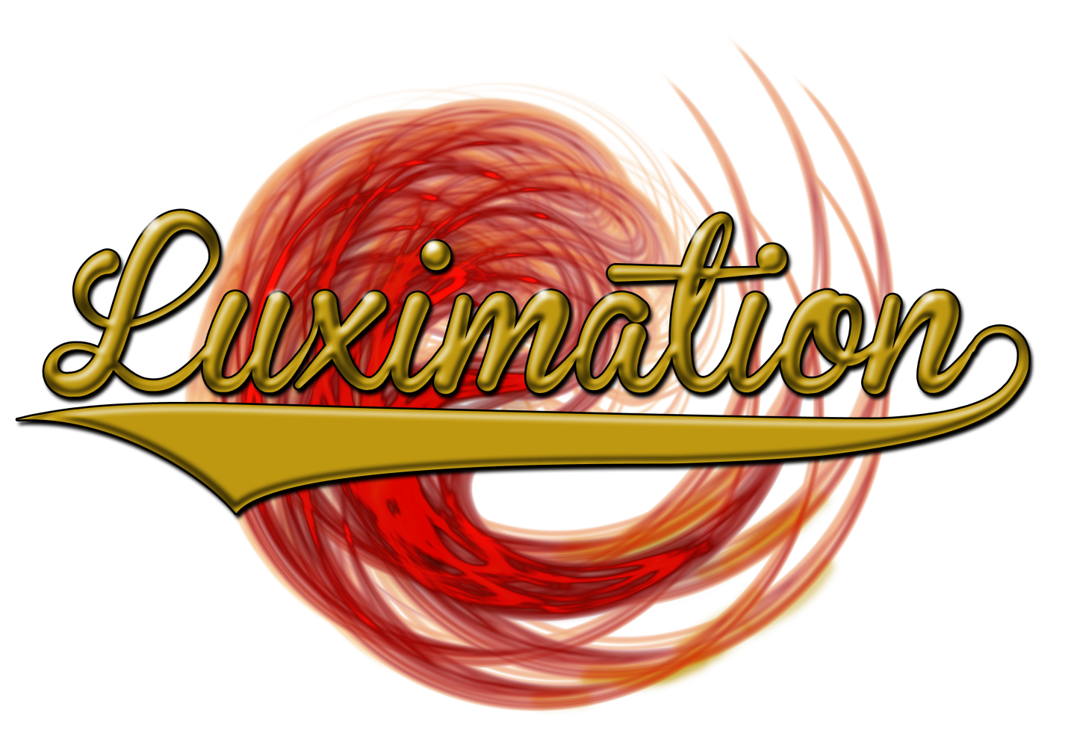
The Source
Can You Survive the Darkness?
Tim Carpenter, Lap Ho Chan, Mike Johnson, Chris Price, Stephen Smith, Chad Travis
4/30/2013

Table of Contents
Introduction 2
Specifications 2
Game Overview 2
Inspiration 2
Controls 2
Main Menu 2
In Game 2
Goal 2
Heads Up Display – Health and Plasma Rifle Energy 3
Saving and Loading 3
Death and Respawning 3
Length of Game 3
Puzzle Components 3
Artificial Intelligence 4
Graphics 4
Introduction 4
Texture 4

Introduction
The Source is a third person shooter. The player is located in a dark cave and must explore the darkness while surviving attacks by enemies and navigating through obstacles.

Specifications
Art was made using 3DS Max or Maya
Developed for Windows and Mac
Built using Unity and C# programming language

Game Overview

Inspiration
The main ideas of this game were taken from Black Swan and the Legend of Zelda. Black Swan is a completely white map allowing the user to throw black paint around to make sense of their surroundings. This idea was translated to light being shot around creating a dark feel to the game. The Legend of Zelda was examined to come up with different puzzles in the game the player needs to solve in order to explore more.

Controls

Main Menu
D – Advance
A – Previous Screen
W – Move Selection Up
S – Move Selection Down
E – Add Character onto Save Name
R – Removes a Character from Save Name

In Game
WASD - Forward/Backward/Strafe
Spacebar - "Freerun" mode, basically removes the gun for climbing/interaction of obstacles
Q - climb object, then use W or Q to continue your climb to the top
R or S - cancel climb
F - "Aim Mode" when the character has a gun in his hand you can access "Aim Mode"
Left Mouse Click - Fire Energy Rounds
Right Mouse Click - Fire Flare
Scroll Wheel - Change Colors
L - Lock/Unlock mouse cursor for better navigation of the player.
W/S - Ledge climbing was made more intuitive by allowing W/S keys to enable climbing up and down once on the ledge.
E/R - Once near a box press E to attach to it then use W/S to push or pull it and use R to release from the box. The character should release from the box if you push it off the edge.
G - Respawn after dying, automatic timer will also cause respawn

Goal
The goal of this game is to explore and become more familiar with the maps. If the player does some actions wrong in a level the player will become stuck. They must be able to navigate the entire area while avoiding this dreadful fate.

Heads Up Display – Health and Plasma Rifle Energy
The player’s HUD is completely integrated within him. His power display is a circle going around his body when walking and ear while shooting. This is his health and energy for his plasma rifle. It drops when he is attacked and by shooting bullets and flares. Shooting flares takes much more power away than bullets. The power recharges over time. Once the player gets into the danger area his gun will no longer work and he must wait for it to recharge.

Saving and Loading
The player selects a name from the main menu and creates the save at that time. The name may be between 1 and 6 characters long. Saving is done automatically whenever a checkpoint has been walked through. These checkpoints are located at the start of every level. The locations of all push boxes are saved and the status of all Lux Lamps is remembered. To load a saved game, the player must select his game save from the main menu.

Death and Respawning
Throughout the game, the player will encounter moments of death. This could be from enemies or falling into a pit of spikes. If the player dies, a ragdoll death occurs. A delay happens then the player is respawned at a location close to where he died.

Length of Game
While playing this game, the player will consume numerous hours exploring the map depending on their knowledge of the world. With the game being complete darkness initially, much of the time needed is exploring the levels trying to figure out what needs to be done.

Puzzle Components
Plasma Rifle – The player’s lone weapon. It is capable of shooting bullets and flares of different colors. This allows the player to take down enemies and operate different puzzles.
Lux Lamp – A permanent Light Source. Activated when the ball is shot with a flare. Helps tell the player where he has explored.
Bridge – Activated by two Light Trails to help navigate the player over large gaps. Shoot the Light Trails switches and see if the color combination activates the bridge.
Light Beam – Sends out a constant source of light to keep switches activated. Combine these together to create a trail of light beam to activate otherwise impossible switches.
Push Box – To block the player and create bridges. Push or pull these around to create a strategic advantage.
Timed Gate – A gate controlled by a switch that closes slowly over time. Shoot the switch with bullets to raise it.
Elevator – An elevator operated by two light trails to move the player between levels. Different color combinations cause different effects: rise, lower, and rotate. Step on the center pad to see if you have the correct combination.

Artificial Intelligence
In this game, enemy behavior is determined by a simple state-based AI. Based on the actions of the player, the AI will move through 4 states: Idle, Suspicious, Pursuing, and Attacking. Depending on the location of the player, location of bullets, location of light flares, and whether or not line of sight exists to any of those objects, the AI will investigate suspicious activities, or pursue and attack the player when detected.
Path finding is handled through a conventional A* implementation. The graph is generated when a level loads. To handle dynamic events in the game, for example the movement of boxes, the graph is updated periodically for a small area around the player. The graph is also used to promote more interesting behavior when multiple enemies are in a non-idle state, by increasing the path cost of nodes to encourage varied path for the active enemies.

Graphics

Introduction
When we set out to develop our game we had decided that we wanted to have next-gen graphics, such as you might see in the Halo series, Call of Duty, or Portal. In order to do that there is a very disciplined process we must go through to keep all the models consistent and comparable to that of a current generation game. The first step, like most other games, begins with concepting.
Rough idea of how the rifle could look like is sketched out on paper or in Photoshop, this then can directly be used to guide in the modeling process later.
Using the concept sketch as a guide rough shapes were blocked out, just enough so that they could be imported into Z-Brush for refinement.

Texture
Next, within Z-Brush, the model is detailed and painted, decimated, UVed, and the high poly details are transferred over to the low poly game model

