The Last Kiwi Design Document

By: Nathan Jacobs, Kevin Solon, Nick Alt, Jin He, Junfei Huang, Josh Adams

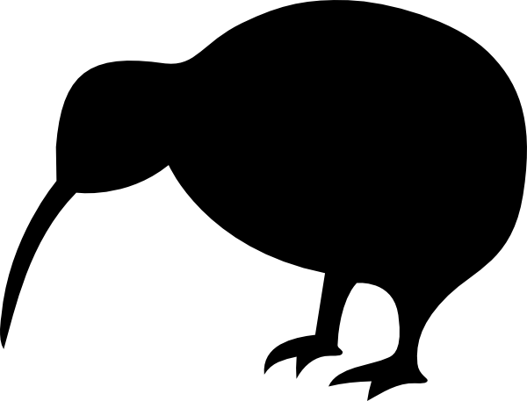

Table of Contents

Title Page 1
Table of Contents 2
Introduction 3
Gameplay 3
GUI 4-5
Enemies 6
Resources + Crafting 6
Weapons 7
Defensive Structure 8
Technical Details 8-10
Game State Diagram 11
References 11

Introduction
The year is 2156 and you are the last kiwi.
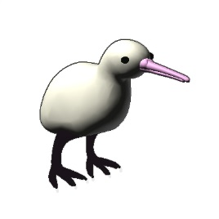
Transported into an alternate dimension by an evil professor you must survive the terrors 2of the void or risk your species extinction.

In order to get back to your dimension you must repair the capsule you arrived in. However the evil professor is determined to make sure you do not return and is sending his fiercest creations to finish you off. Defend your capsule and gather resources from the monsters you defeat to build structures and weapons. Find a way to stop the monster attacks in order to escape.

It is time. Fight or flight, and we all know kiwis can’t fly.
Good Luck.

Gameplay
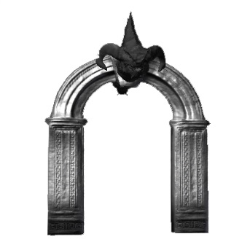
The Last Kiwi is a third person shooter with tower defense elements. You play as a kiwi warped into the void by an evil professor. You must protect your space capsule from waves of monsters at all cost, failure to do so will result in a loss. Monsters spawn in waves form portals. As time progresses more portals with harder monsters will spawn. In order to keep up with the waves of monsters players must destroy the portals they come from while still protecting their generator from other monsters.

To help players manage the increasing difficulty The Last Kiwi has a gathering and crafting system. Monsters you kill will drop resources, use these resources to craft stronger weapons or defensive structures. Along with resources monsters will also drop health packs.

If you manage to destroy enough portals you will draw out the Evil Professor. Defeat him and destroy the rest of the portals to win the game.

Main Menu
On this menu you may navigate through to basic starting areas of the game
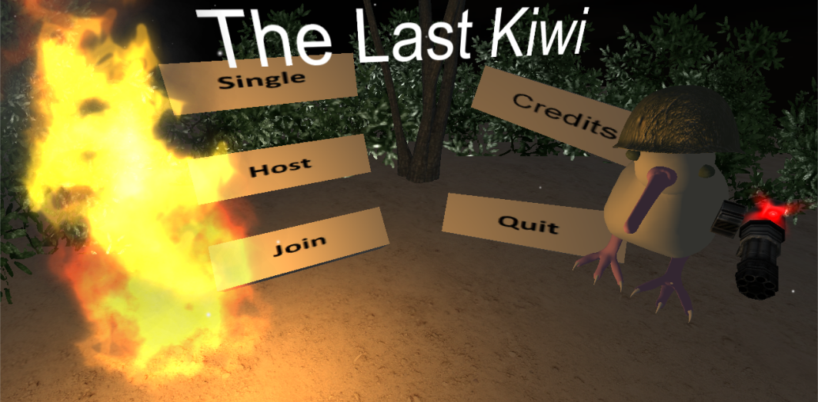

Single Player Start a single player game
Host Game Host a game where others may join in
Join Game Join another match
Credits Credits of the authors of the game
Quit Quit to desktop

Host Screen
This screen gives a set of options to modify the game to be played. They are similar except for a couple extra options for hosting.

Join Screen
This screen gives a set of fields needed to find and join a game or lobby
Refresh Refresh available hosts
Hosts Buttons for connecting to different hosts

HUD
The HUD contains key information and elements for keeping your character alive.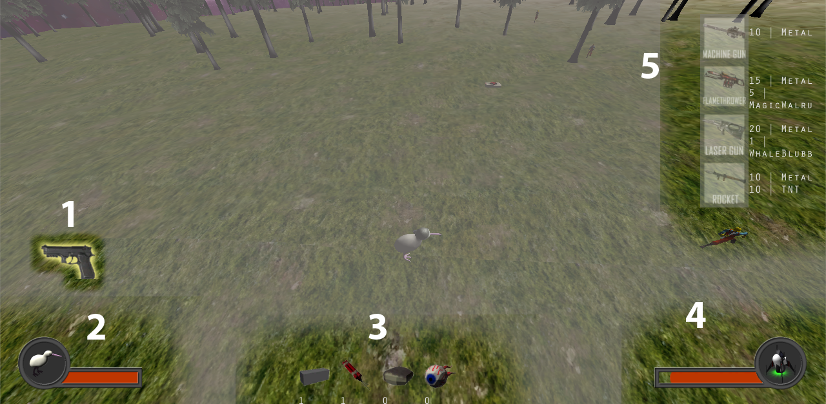
- Selected Weapon - All currently owned weapons are displayed on the side here with the selected weapon highlighted.
- Kiwi Health - The health bar of the Kiwi.
- Resource Counts - A picture of each type of resource with the owned count underneath.
- Ship Health - The health bar for the ship.
- Crafting - Bring up the crafting with the c and v keys. Buttons for each craftable item will appear. Buttons will be greyed out for items that cannot be afforded.

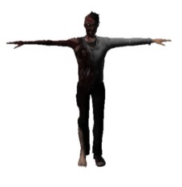
Enemies
Forceful Hugger - The weakest enemy. It will run towards the player dropping mines until it gets close enough to self-destruct.

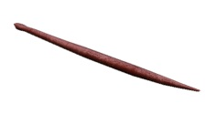
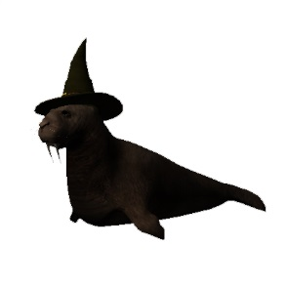
Zombie Snake – Fast and hard to hit. This monster shoots a poison cloud at players and spits out puddles of acid. Its fast speed is balanced by its low health.

Magic Walrus – A glass cannon. The Magic Walrus shoots lasers from its eyes and can teleport around the map making it very hard to kill.

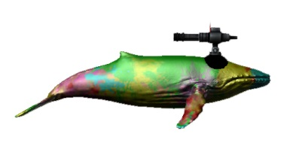
Space Whale – The space whale has the most HP of any monster but is very slow. It shoots rockets from its back and uses a bubble beam when it gets close enough to the player.

??????? – The final boss, Evil Professor C. Spawns after you have killed enough portals, you have no idea what the void will have done to him.

Resources and Crafting
As you progress through the game in order to keep up with the increasing difficulty you will need to craft better weapons and defenses. In order to do this, you will need resources dropped by monsters that you kill. There are four resources in The Last Kiwi: Steel, TnT, Whale Blubber, and Magic Walrus Eyes. The resource dropped is determined by the monster type killed. When you gather enough resources press C or V to open the defense or weapon crafting HUD. The HUD will display a list of items that you can craft long with their cost.
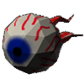
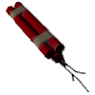

Weapons
There are a variety of types of weapons to help survive and fight off the enemies that are pouring out of the portals. Open the weapon crafting window using the V key. After crafting the weapon of your choice it will be added to your weapon inventory, use the mouse scroll wheel to change between weapons.
Pistol – The player’s starting weapon. The pistol shoots 3 round burst at high accuracy. While fine for taking out early enemies player’s will need to upgrade it as soon as possible.

Machine Gun - The machine gun is a basic weapon that sprays bullets and mows down anything in front of it, its highly effective for bottlenecking enemies and killing them in a choke point. Crafted from steel.

Rocket Launcher – The rocket launcher is an area of effect weapon that does bonus damage to structures. Be careful when using this weapon as it can also damage your nearby defensive structures. Its low fire rate and high damage makes it ideal for taking out portals. Crafted from steel and TnT.
Laser Gun - The laser gun is the most powerful single target weapon in the game. It is however, extremely hard to craft. Crafted from steel and Magic Walrus Eye.

Flamethrower - The flamethrower is another area of effect weapon. Unlike the rocket launcher however it is adapt at killing monsters. Its high damage per second and area of effect make it great for killing enemies you group up using defensive structures.

Defensive Structures
To help you protect your capsule while you are away killing portals players can craft stationary defenses. To craft defensive structures open the crafting HUD using C. After selecting the structure you wish to craft use the mouse cursor to position it on the map and left click to place it.
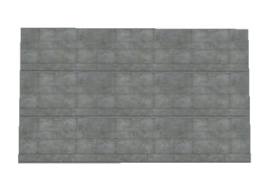
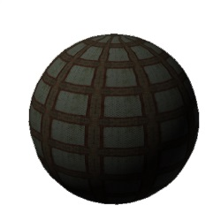
Steel Wall – The most basic defensive structure, use the steel wall to block and funnel monsters into tight spaces. If monsters are blocked by the wall and have no path to you or the capsule they will instead target the wall.

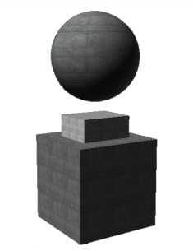
Mine – The mine is made from steel and TnT. Place the mine in narrow areas where monsters are likely to Passover.

Defense Tower – The tower is the most expensive structure you can build, and for good reason. The tower will shoot lasers at nearby enemies. Use it to protect you from swarms of monsters or to protect your capsule while you are away killing portals.

Technical Details
AI
Artificial intelligence is used for the monsters and the defense towers in the game. The behavior of the enemies is controlled by the AI, including how they move, how they attack, how they behave when a large group of them are together, and how they find best path towards the player or capsule. The behavior of defending towers is also controlled by AI. The several AI algorithms are described in detail below.

General enemies moving behavior:
The general behavior of enemies is that they will move towards the generator and if the player is in a predetermined distance from them they will enter the “try to catch player” mode and move towards the player until they catch the player or the player run out of this given range. The speed of the enemies is a predetermined constant which is usually slower than the player to give the player chance to escape.

Flocking behavior algorithm:
As the game goes on, the number of enemies may increase so that you would see a large group of enemies moving towards the same direction, at the same speed. They are probably too close to each other, even overlapping each other and make it difficult to distinguish between them or see them clearly. As a result we need flocking behavior control.

The flocking behavior algorithm is that the velocity of the monsters is a combination of several component vectors and the predetermined weights are given. There are 3 components, including towards player direction velocity (common movement), leaving average position of all the neighbor zombies direction velocity (separation), and the average velocity of all the neighbor zombies (cohesion). We use 1, 1.5, 0.5 respectively as their weights and it looks good. These parameters could be adjusted to make the best flocking behavior that you prefer to see.

Tower defense algorithm
The tower has the ability to automatically find and shoot at the enemies in a predetermined range. The AI controls it so that it will rotate its direction towards the zombie that satisfy a condition (there are three possible conditions) and attack that zombie. The three possible conditions are: the one with shortest distance to the tower, the one with lowest life points, the one with the highest attack ability. The combination of these three conditions is used and 3 weights are given to find a zombie that is with the highest priority to be attacked by the tower. The general idea is: attack the closest enemy, but if several are with similar distance to the tower, then choose the one that is with highest attack (so that this one is first dead and cannot attack the tower) or lowest life point (so that this one is quickly killed and the weapon can deal with others).

Path-finding algorithm
When we control the player and right click the mouse on some other points on the map we would like the player to move to that position through the shortest path, assuming there are obstacles like hills, trees, or walls. The zombies are moving towards the capsule or the player and need to find the shortest path as well.

We use A* algorithm in conjunction with a navigation mesh to find the shortest path. A* uses a BFS (Best First Search) and finds a least-cost path from a given initial node to one goal node (out of one or more possible goals). As A* traverses the graph, it follows a path of the lowest expected total cost or distance, keeping a sorted priority queue of alternate path segments along the way.

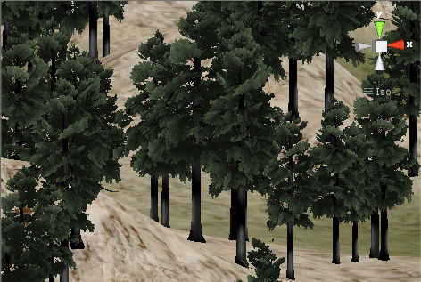
Terrain Generation
The map is a procedurally generated island suspended in space. This is done by using a perlin noise to create a height value for each x,z pair. A vertex shader is applied to vary the texture by height. The result is a completely random map for a different experience each game.
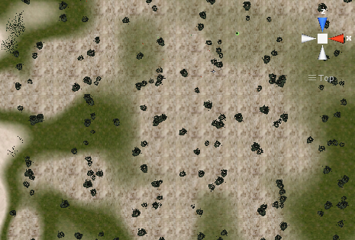
The terrain can be with modified easily to accommodate more complex structures. Mountains and Hills are simple, while Mesas and Canyons are slightly more complicated but have been accomplished in initial testing. Currently the design is set to a floating island.

Data Driven Design
In order to make expanding upon the current iteration as easy as possible we use data driven design for our crafting and monster stats. We use XML files along with Microsoft .Net’s System.XML.Linq library for parsing these files and creating C# objects form them.

Game State Diagram
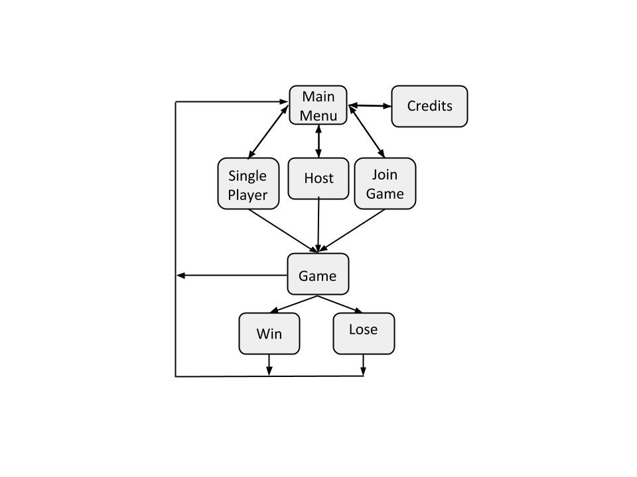
References
Models
Kiwi - http://www.turbosquid.com/FullPreview/Index.cfm/ID/607287
Whale - https://www.assetstore.unity3d.com/#/content/3547
Anti-Tank Mine - http://www.turbosquid.com/FullPreview/Index.cfm/ID/558768
Star Fighter - http://www.turbosquid.com/FullPreview/Index.cfm/ID/459058
War Helmet - http://www.turbosquid.com/FullPreview/Index.cfm/ID/764462
Snake - http://www.turbosquid.com/FullPreview/Index.cfm/ID/574922
Stone Arch - http://www.turbosquid.com/FullPreview/Index.cfm/ID/618552
Dragon Head - http://www.turbosquid.com/FullPreview/Index.cfm/ID/668714
M1911 Pistol - http://www.turbosquid.com/FullPreview/Index.cfm/ID/724710
Witch Hat - http://www.turbosquid.com/FullPreview/Index.cfm/ID/625149
Walrus - http://tf3dm.com/3d-model/walrus-seal-44778.html
Demon - https://www.assetstore.unity3d.com/#/content/2971
Pictures
Kiwi Image: http://vector.me/files/images/1/9/191815/kiwi_bird_clip_art.jpg
Pistol Image: https://encrypted-tbn0.gstatic.com/images?q=tbn:ANd9GcSDHxK8qZT_9unKoeEi0yq89unAIgKAEMVWF1BPE4LnC2haVKKl
FlameThrower Img: http://fc05.deviantart.net/fs71/i/2012/169/a/e/commission_concept_art___flamethrower_by_torvenius-d53xfws.jpg

