Design Document for:

OgreGolf

Party Golf Game Designed By OgreGolf Team
Spring quarter 2009

Table of Contents
- Game Overview__________________________________________________________________3
  - What is OgreGolf? __________________________________________________________3
  - Rich Environments___________________________________________________________3
  - Control Your Golfer__________________________________________________________3
- Features_________________________________________________________________________4
  - Terrain____________________________________________________________________4
  - Physics____________________________________________________________________4
  - Sound_____________________________________________________________________4
  - Artificial Intelligence_________________________________________________________4
- Gameplay_______________________________________________________________________5
  - Power-Ups_________________________________________________________________5
  - Menu System_______________________________________________________________5
- Player Controls___________________________________________________________________6
  - Direction/Arc Phase_________________________________________________________6
  - Power Phase_______________________________________________________________6
  - Curvature Phase____________________________________________________________6
  - Hit Phase__________________________________________________________________6
- Third Party Components__________________________________________________________7
- Game Flow Diagram______________________________________________________________7
- Credits__________________________________________________________________________8

1.0 Game Overview
1.1 What is Ogre Golf?
Ogre Golf is a turn-based golf party game that pits up to 16 players (human or AI) against each other in a wacky "mini-golf on a real golf course" style of gameplay. Throughout the golfing process the player must dodge obstacles such as castles, giant fire hydrants, and warlocks while trying to hit power-ups. The ultimate goal is to get your ball in the hole in less strokes than the other players while having fun in the process.

1.2 Rich Environments
This game has used third party software (such as Hydrax, Caelum, and Artifex Terra) along with some of our own implementations (such as static obstacles and interactive green) in order to create a realistic rich environment. The terrain, surrounding ocean, and skies will exhibit a startling sense of realism, while the outrageous obstacles, characters, and power-ups on the map will provide a stark contrast to this realism. You will have to golf through fields of fire hydrants, castles, and warlocks while trying to hit good power-ups and achieving your ultimate goal of sinking the perfect putt.

1.3 Control your Golfer
“Whack that Ball, but Aim Well “
Each human player is a ninja and each CPU player is a Robot. The CPU players have variable strength and accuracy, whereas the human strength and accuracy is completely dependent on the players timing. The power levels are much higher on the fairway than the rough so aim wisely. The Player must also avoid many obstacles while shooting or use the obstacles to his/her advantage.

2.0 Features

2.1 Terrain

-Expansive 3-D landscapes
-Dynamic time of day
-Dynamic day and night ambient noise
-Beautiful oceans
-Completely Collision Detection
-Vast Green Landscape

2.2 Physics
-Realistic modeling of golf-ball physics
-Player modifiable map-specific settings, such as gravity, friction, and restitution
-Complete collision detection and reaction of ball on terrain and other static objects

2.3 Sound
-Rich 3-D sound effects
-Ambient outdoor sounds that immerse the player in the environment
-Dynamic ambient noise changing with day/night cycle

2.4 Artificial Intelligence
-Computer opponents with variable accuracy and power
-An ogre will run around the map, trying to eat the ball of the winning player

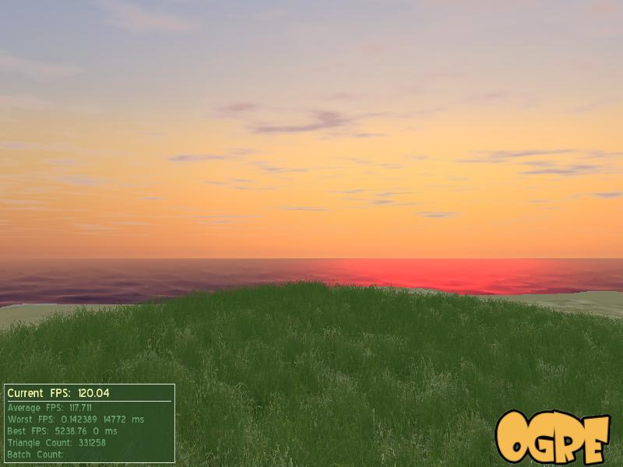

3.0 Gameplay
-Up to 16 players
-Intuitive controls
-Party-game like atmosphere

3.1 Power-ups

Scattered around the map randomly
Activated by hitting them with your ball
Increase or decrease your total strokes
Smiley Face is good Power-Up
Frown Face is a bad Power-Up
Dynamic particle effects to make power-ups more visible

3.2 Menu System
You can skip the splash screen by pressing space.
Once in the main menu, you have several options.

-Start Game
-Name Your Players
-Decided which players should be AI and which should be human
- Clickable button between 'Human' and 'CPU'
-Options
-Sound level options
-Credits
-Credits for the game itself
-Recognition to people who have helped along the way
-Quit
-This will exit the game
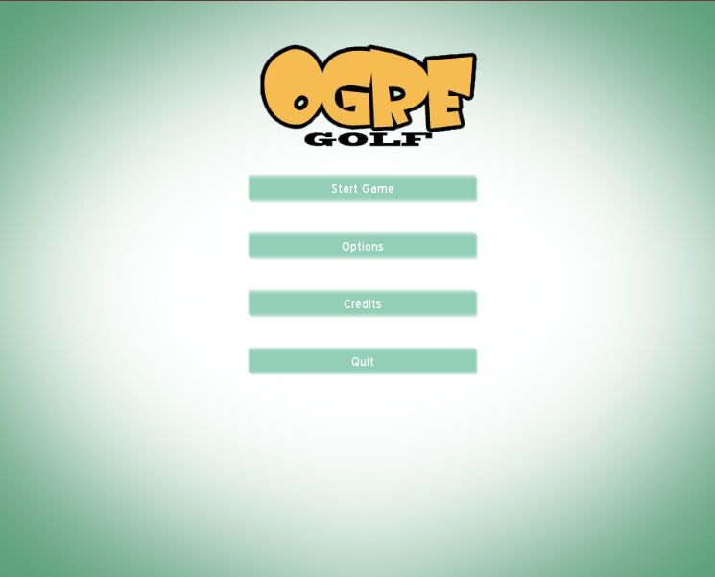

4.0 Player Controls
Each turn consists of four main phases:

4.1 Direction/Arc Phase
-In this phase, the player selects the direction they would like to hit the ball, and the arc of the shot.

-Left/Right arrow keys or mouse motion while left button is held - rotate camera/player and direction of shot

-Up/Down arrow keys or mouse motion while left button is held - adjust arc of shot

-Mouse motion while right button is held - zooms in/out on player

-Spacebar - Locks in direction and arc

4.2 Power Phase
-In the power phase, the player locks in the power of the shot. The arrow contracts and expands continuously, representing the possible maximum and minimum power. The player must lock in the power they want by careful timing.

-Spacebar - Locks in power, which corresponds to the length of the arrow when spacebar is hit

NOTICE: Power phase changes dependent on where the ball is on the map. Player is most powerful on fairway.

4.3 Curvature Phase
-In the curvature phase, the player locks in the curve of the shot. The arrow twists back and forth, representing the precision and accuracy of the shot. The player must lock in the exact direction they want by careful timing.

-Spacebar - Locks in curvature, which corresponds to the direction of the arrow when spacebar is hit.

NOTICE: Curvature phase changes dependent on where the ball is on the map. Curvature phase is slowest on the fairway.

4.4 Hit Phase
After completing the previous phases, the player can sit back and watch as the character hits the ball with the direction, arc, power, and curvature selected from the first three phases. Cameras will dynamically follow the ball after it is hit, and until it comes to a stop.

5.0 Third Party Components
Bullet- Physics engine <http://www.bulletphysics.com>
BtOgre- Bullet wrapper <http://www.ogre3d.org/forums/viewtopic.php?f=5&t=46856 BtOgre>
FMOD- Our sound engine <http://www.fmod.org Fmod>
Lua- Our scripting engine<http://www.lua.org Lua>
LuaBind- Our Lua wrapper<http://www.rasterbar.com/products/luabind.html Luabind>
Boost - Supplemental headers to the Luabind library< http://www.boost.org Boost>
Ogre - Our graphics engine< http://www.ogre3d.org Ogre>
Caelum - Our atmospheric addon< http://www.ogre3d.org/wiki/index.php/Caelum Caelum>
Hydrax - Our water addon< http://www.ogre3d.org/wiki/index.php/Hydrax Hydrax>
Artifex Terra - Our terrain editor addon< http://www.artifexterra3d.com Artifex Terra>

6.0 Game Flow Diagram
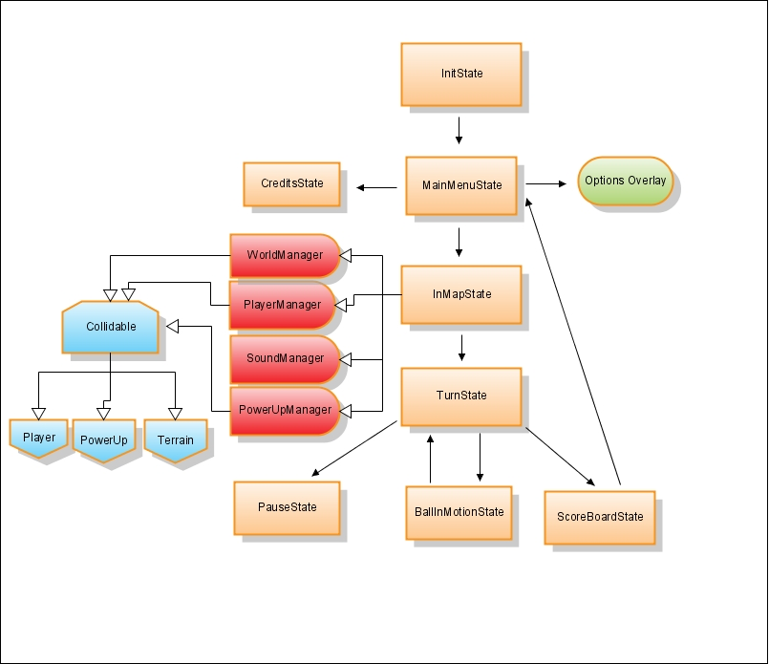

7.0 Credits
7.1 Creators:
Clayton Snyder
Jeff Ridenbaugh
Zach Howard
Dan Wagers

7.2 Sound Recognition
Freesound.org
vocalized-wah.wav by FreqMan
Ploppy_1.wav by digifishmusic
Gentle Sea On Flat Beach.wav by digifishmusic
Rooster1.wav by acclivity
rbh city night crickets.wav by RHumphries
Wind.mp3 by acclivity
rbh mocking bird.wav by RHumphries
pingpong2.aif by Timski
Drop ball in cup-3.wav by AGFX
GolfTeeOff2.flac by acclivity
smallcrowd.wav by sagetyrtle
GolfTeeOff3.flac by acclivity
Golf - Golfswing with 3WD [1].wav by robbera
grass4.wav by Snoman

7.3 Model Recognition
Baumgarten Enterprises, www.baument.com:
CASTLE1.3DS
MedMan25.3DS
FireHyd.3DS
Ogre Team
Jeff Ridenbaugh

