Snow Day
Game Design Document

Paul Breuler
Jacob Edelen
RJ Kucia
Mitchell Loveall
Kevin Smearsoll
Alan Thornburg

Table of Contents
Introduction
Game State Diagram
Overview
Art Style
Controls
Movement
Weapons
Game Modes
Free-For-All
Capture-The-Flag
Team Deathmatch
Domination
Respawning
Tutorial
Singleplayer
Multiplayer
Player Health
Building Mechanic
Classes
Fighter
Sniper
Engineer
Bruiser
Healer
Wizard
Levels/Level Design
Weather System
Artificial Intelligence
Computer (“Bot”) Players
Snowmen
Introduction
Snow Day is a class-based, snowball shooter game that will have many different game modes for both casual and competitive play. [To be expanded when classes and levels are complete or at least more fleshed out].

Game State Diagram
[To be created and inserted when more of the game is complete]

Overview
Art style
Snow day will not be a gritty realistic shooter. Instead the art style will be similar to that of an anime giving it a slightly gritty appearance as to not overdo the cartoonish nature of the game.
[Sample of art style here]

Controls (Movement and Weapons)
Movement
Movement will use the standard unity character controller with the exception that the player will be able to swap between first and third person views. Fall damage will be applied to high drops.
Weapons
The control scheme will follow an FPS style of input. The exception to this will be that the main weapon, the snowball, will require charge to throw greater distances. In addition the aiming reticle for the snowball will translate across the screen to indicate where the snowball will approximately land based on movement speed and stance. Other weapons will follow the more traditional point and shoot method unless they are also a special weapon type.

Game Modes
Free-For-All
Free for all will be a simple game mode in which the player with the highest number of knockouts wins.
Capture-The-Flag
Capture the flag will pit opposing teams against one another to capture one anothers flag. There is no building in this mode. Player will respawn after a short duration when knocked out.
Team Deathmatch
Team death match will consist of opposing teams attempting to reach some predefined score which accumulates with each K.O. of a player on the opposing team and can be reduced from friendly fire.
Domination
Domination will allow players to build bases around 3 points of interest (POI) in an attempt to maintain control for the longest time. When a POI is neutral either team may build. However, when a POI is captured only the controlling team may build. Upon losing control of the area the structure currently in place is destroyed and the new team must build quickly to defend the area. A slight boost to build speed is given for the first X seconds of a new capture.

Respawning
Since Snow Day is a less violent FPS when a player is “Knocked out” an evil snowman will erupt from the ground and drag them back to their respective spawn point after a short duration. During the time the player is waiting he or she will be able to view the location of their demise via a death camera. Other player will be able to knock around the victim who will react with ragdoll physics.

Tutorial
A simple tutorial level will be designed to aid players in learning the basics of Snow Day’s gameplay features. [To be completed in a later Timebox]

Singleplayer
Single player mode will allow a player to enter a game with bots only for practice. [To be completed in a later Timebox - bots still need to be fully implemented]

Multiplayer
Multiplayer will consist of a simple matchmaking setup with custom game creation. Players will be able to enter their username and join friends online or join a random match. At the end of each match player will be able to vote on the next match. In the case of a custom game the game master may choose to select the next round or create a lineup of levels.

Player Health
The game will use a modified health system, where a player's health is dependent upon the temperature of their character in addition to the standard hit point scheme. There will be ways for a player to both increase and decrease their character's temperature during battle which relates to how many hit points they have. A character is "killed" when their hit points have been reduced to zero. [To be completed in a later Timebox]

Building Mechanic
Given that the game occurs in areas where there is an abundant amount of snow around, each class will be able to build using the snow in some way. In general, the characters can use the snow to lay down blocks which can eventually form things like walls and forts. [To be completed in a later Timebox]

Classes
Players will have the ability to choose a character class at the beginning of each match and after each death during the match. [To be completed in a later Timebox]
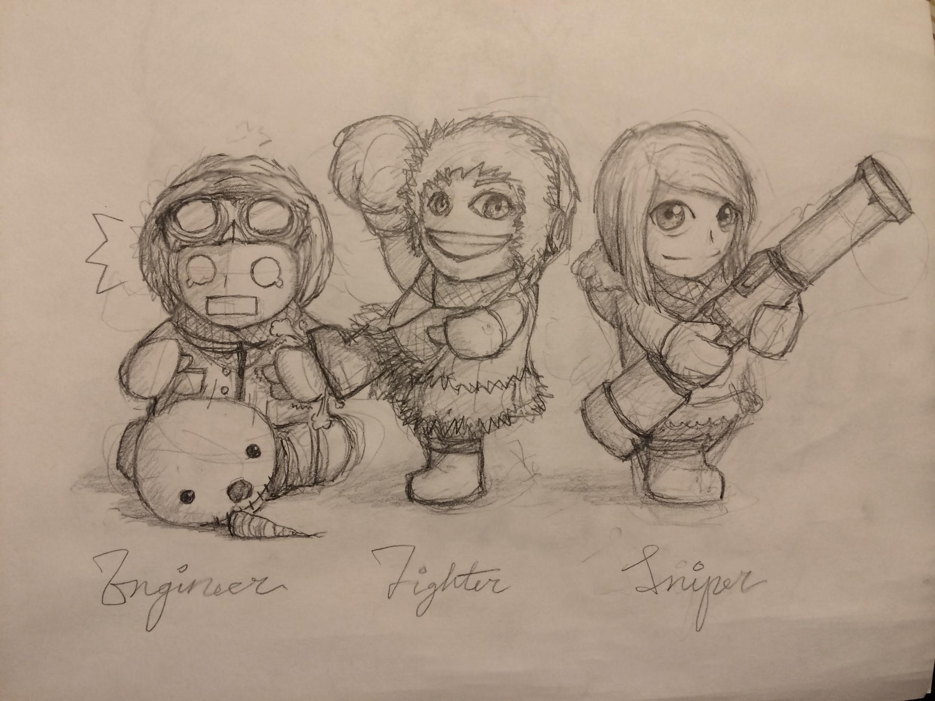
Fighter
The fighter is a well rounded class which serves as the base player for the game.
Weapons
- Snowball
- Alternate???
Abilities:
- Basic building

Sniper
The sniper will have lower hit points than the fighter. However, her ability to cause greater damage will offset her lack of HP.
Weapons
- Snowball
- Sniper
Abilities:
- Precision Shot (sniper)
- Basic building
Engineer
The engineer will have slightly lower HP than the fighter. The engineer will have the ability to create turrets, while focusing on building strong defenses.
Weapons
- Snowball
- Wrench ???
Abilities:
- Snowman Turret
- Improved building

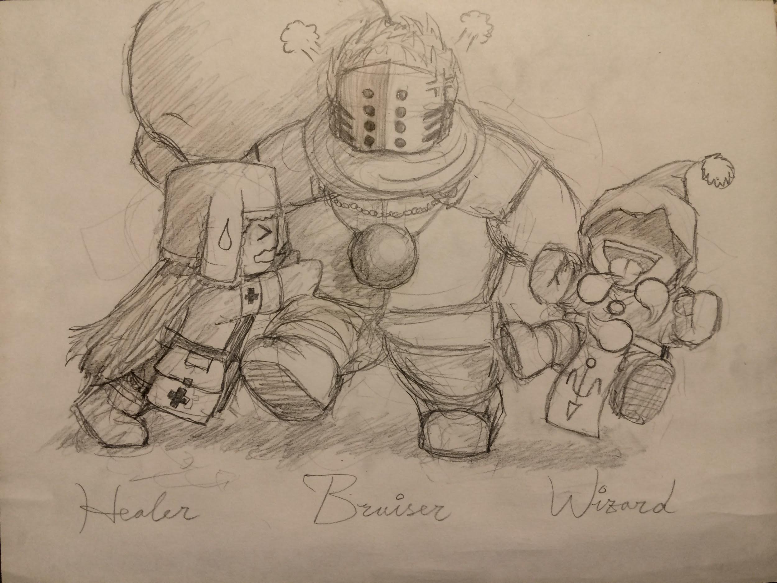
Bruiser
The bruiser is the neighborhood bully. He is not out to have fun with the other kids. Instead, the bruiser is looking to pwn some noobs and watch the tears flow. He will move slow but have higher hit points than the fighter.
Weapons
- Large Snowball
- Fists
Abilities:
- Pummel (Breaks through defences and/or causes a great deal of damage to a player)
- Basic building

Healer
The healer will have less hit points than the fighter.
Weapons
- Snowball
- Alternate??
Abilities:
- Warm (Heal nearby friendly or melt defences)
- Basic building
Wizard
The wizard will have less hit points than the fighter but will deal greater damage with his spells. However, his attacks will have longer cooldowns.
Weapons
- Snowball blast - launches the snowball with greater starting velocity than others. Does not require throwing given that the wizard uses his powers to launch the snowball. Has a slightly longer cooldown than other players.
- Magical ability
Abilities:
- Mighty Blast -- breaks a snowball into 3 smaller packed snowball which blast out in a spiral dealing slightly less damage individually than the snowball but if a direct hit is made it will deal 2.5x the damage and slow the tarted for 1 second.
- Basic building

Levels/Level Design
Levels will consist of small town neighborhood themed levels. For example, one level will be the local park and another will be the cul-de-sac of the neighborhood. [To be completed in a later Timebox]

Weather System
The weather system will control two aspects of the environment: the temperature and the precipitation. A changing temperature will alter both physics and player health. The snow/ice around a level will either freeze or melt in response to the temperature, which will cause characters to slide more or less as they move around. Additionally, because player health will be based on the character's temperature, temperature change will change how players have to play the game; a higher temperature means that the player can move less, while a lower temperature means that a player must perform slightly more actions in order to stay warm. In addition to the temperature, the system also controls the amount of precipitation occurring at any given time. The precipitation amount will only affect a player's vision; more snowfall will make the environment (and other players) harder to see, while less snowfall will have the opposite effect.
Weather will hopefully be procedurally controlled; that is, it should have limits that control how much or little it can change during a battle. Procedural control will allow for more precipitation and, in general, more factors that make gameplay more difficult during Sudden Deaths. [To be completed in a later Timebox]

Artificial Intelligence [To be completed in a later Timebox, but close]
Computer (“Bot”) Players
While the main focus of the game will be on multiplayer gameplay, computer players will be available as well. These computer players will behave similarly to human ones, and will have access to the same characters and abilities. Suitable artificial intelligence algorithms will be researched, and the best available one will be implemented. The goal of this will not be to develop an AI that will dominate the players; rather, the goal is to provide an option for players who do not have enough human players. These computer players can also provide opportunities for single-player missions, if the team chooses to develop these in the future.
At this point, the AI is able to identify enemy players within its field of vision, and aim and throw snowballs at the closest enemy. Multiple AI players can be added to a game. They will not attack or damage players on their own team.
Snowmen
Unlike the normal computer players, snowmen will act very differently than human players. They will act as autonomous turrets, throwing snowballs at enemies as they go by. The can either be created by players or be integrated into the environment. Their logic will be simpler than the normal computer players, as they will be stationary.

